Title: Advisor – Infrastructure Delivery
Group: Corporate Services
Reports to: Manager - Infrastructure Strategy and Delivery
Location: Wellington
Direct Reports: No
Budget: No
OUR ORGANISATION
About us | Oranga Tamariki—Ministry for Children is a Ministry dedicated to supporting any child in New Zealand whose wellbeing is at significant risk of harm now, or in the future. We also work with young people who may have offended, or are likely to offend. Our belief is that in the right environment, with the right people surrounding and nurturing them, any child can, and should flourish.
Our vision | Our vision is: New Zealand values the wellbeing of tamariki above all else.
Our purpose | Our purpose is: To ensure that all tamariki are in loving whānau and communities where oranga tamariki can be realised.
The Oranga Tamariki way | We’re introducing a new way of doing things. A way of looking at the world that guides everything we do:  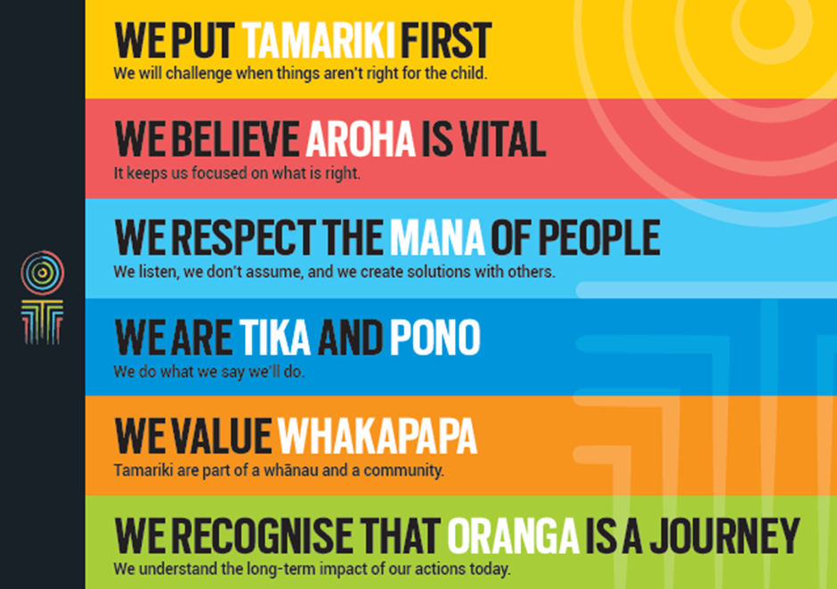
Our core outcomes | Our core outcomes are:  - All children and young people are in loving families and communities where they can be safe, strong, connected, and able to flourish  - Improved outcomes for all children, especially tamariki and rangatahi Māori.

POSITION PURPOSE
The Advisor Infrastructure Delivery is responsible for providing advice and support that helps ensure staff have the infrastructure (physical sites, facilities and vehicles) they need to effectively carry out their jobs and realise the Oranga Tamariki vision.
KEY ACCOUNTABILITIES
Key Result area | Key Accountabilities
Infrastructure Support | - Establish and maintain processes and documentation related to infrastructure management and the infrastructure programme  - In conjunction with the Ministry of Social Development (MSD) Property (shared services) team, maintain a clear current state view of our property portfolio including condition, usage and capacity.  - Actively manage the capacity of our commercial property portfolio in conjunction with local and regional teams, and provide advice on future needs  - Help ensure that information flows and sequencing of decisions across the infrastructure programme is well managed  - Support the infrastructure programme and specific project teams as required.
Infrastructure Advice | - Contribute to advice on the overall Infrastructure programme, processes and operations of Oranga Tamariki  - Contribute to advice and oversight of the internal programme and project groups, and other advisory bodies and committees (internal and external)  - Liaise across Oranga Tamariki to ensure policies, delegations and other documents are aligned  - Carry out activity that supports the health and integrity of the infrastructure programme and project framework, processes and operations.
Infrastructure Secretariat | - Contribute to an efficient and effective secretariat function for the infrastructure programme and related governance, project and working groups, including but not limited to:  - meeting administration – scheduling meetings, agenda, collation and distribution of papers, distribution of minutes, following up action points;  - meeting attendance – capturing key discussion points, decisions and action points; and  planning and development – forward work programme development, terms of reference, and updating intranet content.
Relationship Management | - Build and maintain strong working relationships with relevant teams, senior managers and advisors across Oranga Tamariki to enable the provision of infrastructure related advice  - Build and maintain strong working relationships with people across Oranga Tamariki to ensure programme and project processes are followed  - Build and maintain strong working relationships with programme and project teams.
Continuous Improvement | - Identify and make improvements to infrastructure processes and systems  - Contribute to the development and conduct of evaluations of programmes and projects to ensure effectiveness and efficiency.
Being part of the Oranga Tamariki team | - Actively and positively participate as a member of the team  - Proactively look for opportunities to improve the operations of Oranga Tamariki  - Perform any other duties as needed by Oranga Tamariki  - Comply with and support all health and safety policies, guidelines and initiatives  - Ensure all incidents, injuries and near misses are reported into our H&S reporting tool  - Comply with all legislative and regulatory requirements, and report any breaches as soon as they become known  - Adhere to all Oranga Tamariki procedures, policies, guidelines, and standards of integrity and conduct  - Commitment to the Treaty of Waitangi and respect and incorporate these into your work.
KEY RELATIONSHIPS
Internal | - Technology, Infrastructure and Commercial team  - Oranga Tamariki Managers and staff  - Business unit members that the project is delivering to
External | - External Contractors  - Staff in other government agencies including Police  - Ministry of Social Development  - NGOs
QUALIFICATIONS & EXPERIENCE
Qualifications | - A tertiary qualification in a related area or equivalent operational experience is preferred.
Experience | - Collating information and turning it into advice  - Working in the public sector, ideally with an understanding of organisational governance  - Working across an organisation and influencing without formal authority  - Managing multiple pieces of work with varied and competing timeframes  - Developing, maintaining, and documenting systems, processes and practices  - Providing secretariat services and advice to committees, boards, project teams other similar groups.
Skills | - High level of integrity, professionalism and discretion  - Analytical skills with the ability to make sound and respected decisions  - Ability to effectively manage or escalate issues  - Ability to write to a high standard, appropriate to the audience, including proof reading with a high level of accuracy  - Highly organised with the ability to manage multiple pieces of work, prioritise and cope with the pressure of meeting fixed timeframes  - Build and maintain relationships across an organisation, using appropriate style and method to communicate with others  - Ability to design and implement pragmatic process design and improvement.
Other | - Willing to travel within New Zealand to fulfil job requirements such as supporting meetings held outside of Wellington.

