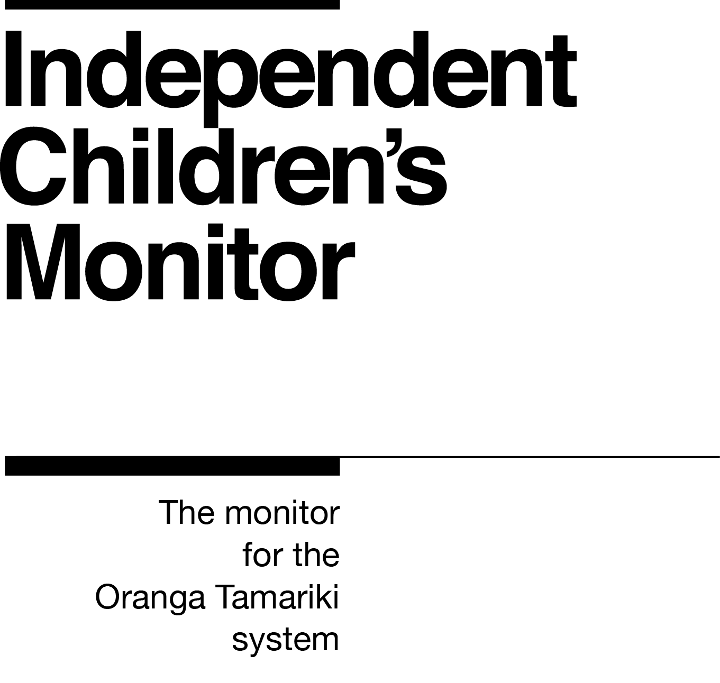

Kaitātari Aporei, Kaupapahere Rauemi
Principal Advisor Operational Policy and Practice

Our purpose
The purpose of the Independent Children’s Monitor (the Monitor) is to provide a credible view of the Oranga Tamariki System, highlighting areas that will drive continuous improvement and improve outcomes for children and young people, particularly tamariki Māori.
How we do this
The Monitor has oversight of the Oranga Tamariki System and its work will reflect the broad spectrum of monitoring from compliance, to practice quality, through to outcomes. Monitoring each of these interrelated areas enables us to assess if outcomes are being achieved for tamariki (children) and rangatahi (youth). Our review, analysis and reporting functions drive improvement and give us the opportunity to provide accurate information to a range of audiences including Ministers, government agencies, iwi, non-government agencies, whānau and individuals on the performance of the System.
We strive to always work in a way that is child-centred, embeds te ao Māori, is insight-driven and builds on our reputation as a trusted and credible influencer.
Our values

Kia Māia – Courageous: We are brave, bold, capable and confident.
Kia Pono, Kia Tika – Trustworthy: We are honest and genuine.
Manaaki – Respectful: We show respect and care for others.
Kia Huritao – to be Reflective: We are considered and reflective.
Our commitment to Māori
As a Te Tiriti o Waitangi partner to we are committed to supporting and enabling Māori,
whānau, hapū, iwi and communities to realise their own potential and aspirations.

Position detail
Overview of position
The Kaitātari Aporei, Kaupapahere Rauemi/Principal Advisor Operational Policy and Practice develops new operational policies and associated practice documentation for the Monitor, and updates existing operational policies and practices, in a way which is in line with legislation and policy intent. The Principal Advisor provides advice to the General Manager Operations and the Managers Monitoring on operational policy to ensure accurate and full understanding and universal uptake of operational policy.
The Kaitātari Aporei, Kaupapahere Rauemi/Principal Advisor Operational Policy and Practice maintains an overview of new “big P” policy and policy changes to ensure operational impacts are identified and well understood by decision makers. They proactively identify areas where policy could be amended or improved in order to deliver better outcomes for children and young people. They also liaise with key stakeholders to promote the interests and objectives of the Monitor.
Location
National Office, Wellington.
Reports to
Kaitohu, Rangapu, Rautaki me ngā Māramatanga/Director Corporate, Strategy and Insights.

Key responsibilities
Developing operational policy and supporting practice tools and resources
- Working within strategic policy frameworks to translate strategic policy into high quality operational policy through analysis of issues, development of alternative solutions, and assessment of their feasibility and presentation of recommendations.
- Leading the design and development of systems, methodologies, tools and policy instruments required to translate policy into operational practice and working with the General Manager Operations and their teams to assure their effective use.
- Providing high quality operational policy advice and support to the Monitor and providing guidance on how statutory requirements and Government decisions could be implemented.
- Providing analysis and advice to other government agencies that are working on related issues and contributing to the effective integration and co-ordination of policies from other government agencies where relevant.
- Leading the co-ordination of information collection, planning and consultation processes which feed into the development of operational policy design.
- Utilising knowledge of machinery of government and legislative processes to ensure compliance with statutory/regulatory requirements.
- Researching international practice and performance to inform operational policy development.

Actively building trusting and professional relationships
- Building strong relationships across the Monitor’s front-line team to ensure a comprehensive understanding of the monitoring function and operating model and the priorities for operational policy development or improvement.
- Building relationships with the Policy Group to ensure an oversight of any new or updated “big P” policy that may have operational implications, and to be in a position to provide operational insight to inform policy development.
- Finding opportunities to learn about other organisations and services to improve operational policy and practice.
- Utilising experience, knowledge, skills and capabilities to confidently and respectfully engage with external stakeholders to improve operational policy where appropriate.
- Maintaining the balance of strong affiliative relationships without compromising professional boundaries.
Embedding child-centred practice
- Using experience and knowledge to support the Monitor to embed child-centred practice into the status quo through making children’s participation and the voice of tamariki front and centre of the Monitor’s design, decision making and day-to-day operations.
- Using experience, knowledge and capabilities to confidently engage with tamariki and their whānau.
- Ensuring that in embedding child centred practice, there is an understanding that a child needs to be seen in the context of their whanau.
Embedding te ao Māori
- Building knowledge, experience, capability and understanding of tikanga Māori and te reo to confidently engage with whānau, hapū and iwi.
- Embedding te ao Māori into the status quo of the Monitor.
- Seeking advice and using empathy and judgement to adapt to the cultural context.
- Being culturally authentic - identifying with and learning about cultural similarities and differences

Health, safety and security
- Understanding and implementing your Health, Safety and Security (HSS) accountabilities as outlined in the HSS Accountability Framework
- Ensuring you understand, follow and implement all health, safety and security and wellbeing policies and procedures.
Emergency management and business continuity
- Remaining familiar with the relevant provisions of the Emergency Management and Business Continuity Plans that impact your business group/team.
- Participating in periodic training, reviews and tests of the established Business Continuity Plans and operating procedures.
Other duties as required

Know-how
Operational policy - previous experience in developing operational process and best practice in a Service Delivery environment and proven expertise translating legislation and/or regulations into operational policy.
Sector knowledge - technical and professional knowledge in social sector/human services.
Relationship management – excellent ability to make meaningful connections with a wide range of people and organisations, one-on-one and collectively, and build lasting professional relationships.
Strong writing skills – proven ability to write clear, concise reports, business cases, memos and other professional documents.
Analytical thinking – strongly demonstrated expertise in considering a range of information and drawing conclusions, researching and producing credible evidence to support operational policy direction.
Thought leadership – the ability to innovate, use initiative and provide thought leadership to the Monitor.
Legislation and statutory obligations – proven ability to quickly build knowledge and understanding of relevant statutory and public service processes and experience in the interpretation and application of legislation.

Attributes
- Resilient
- Initiative
- Influencer
- Problem solver
- Relational

Key Relationships
Internal
- Independent Children’s Monitor colleagues
- Ministry of Social Development’s Policy colleagues
External
- Oranga Tamariki colleagues
- NGO provider colleagues
- Office of the Children’s Commissioner colleagues
- Māori provider colleagues
- Other government agency colleagues – particularly operational policy colleagues

Other
Delegations
Financial – None
Human Resources – No
People – None
Direct reports –No
Security clearance – Yes
Children’s worker – Yes
Limited ad hoc travel may be required.
May require after-hours work.

Our future
The Ministry of Social Development (MSD) has been given the job of building the Independent Children’s Monitor (the “Monitor") and the initial phases of monitoring operations. The Government has decided, in principle, to transfer the monitoring function to the Office of the Children’s Commissioner (OCC) once new legislation is passed and the Monitor is well established. The Monitor has been directed to report back to Ministers in March 2021 on the plan, timeframes and readiness for the transfer of the Monitor. This means that the Monitor is currently part of MSD, however it is likely that it will transfer to be part of another organisation in the future.

