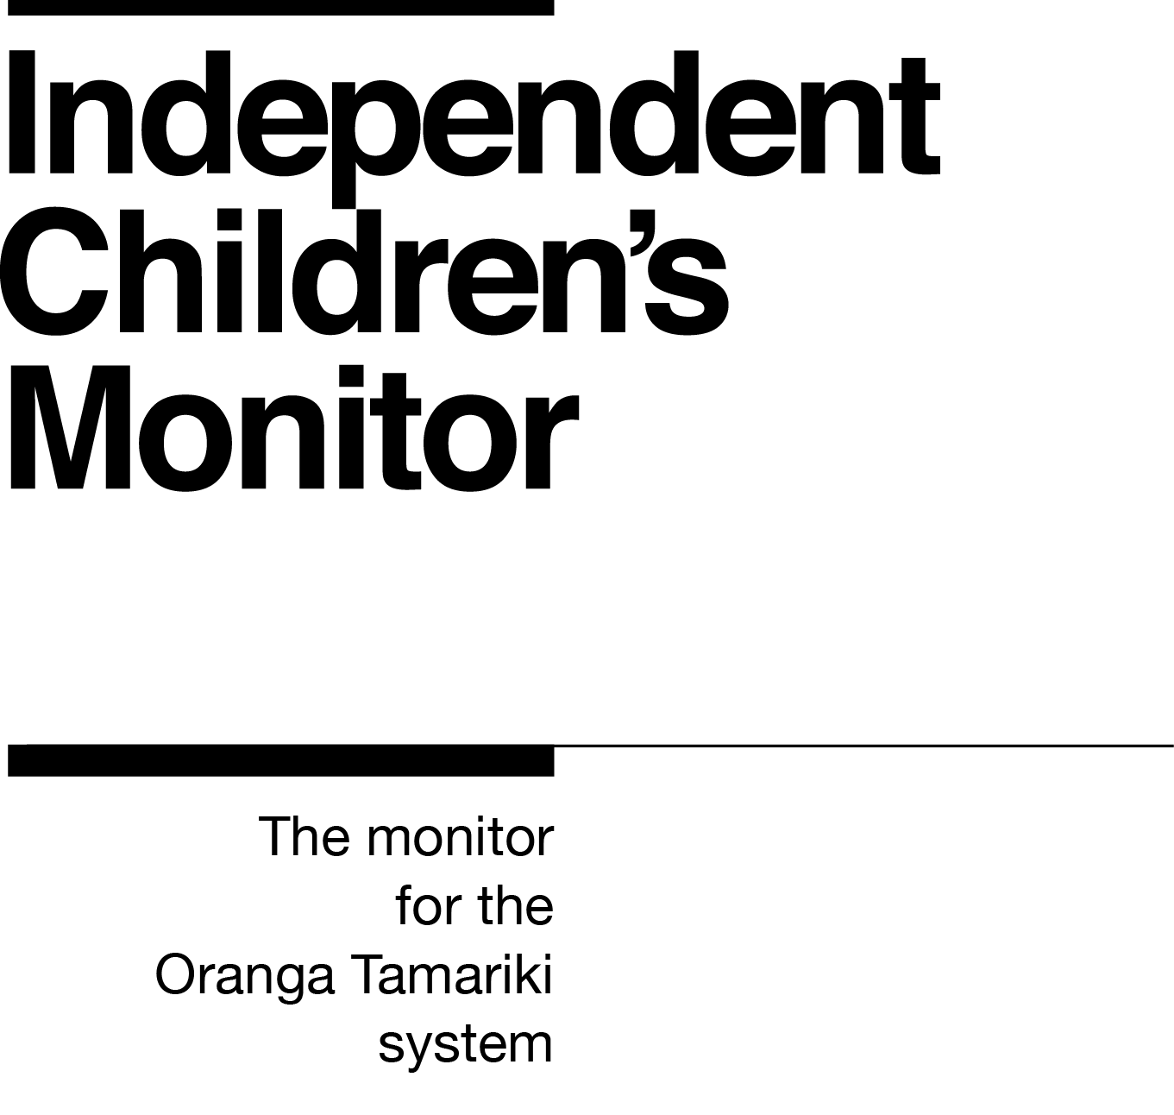

Kaiarataki Tikanga
Practice Lead

Our purpose
The purpose of the Independent Children’s Monitor (the Monitor) is to provide a credible view of the Oranga Tamariki System, highlighting areas that will drive continuous improvement and support improving outcomes for children and young people, particularly tamariki Māori.

How we do this
The Monitor has oversight of the Oranga Tamariki System and its work will reflect the broad spectrum of monitoring from compliance, to practice quality, through to outcomes. Monitoring each of these interrelated areas enables us to assess if outcomes are being achieved for tamariki (children) and rangatahi (youth). Our review, analysis and reporting functions drive improvement and give us the opportunity to provide accurate information to a range of audiences including Ministers, government agencies, iwi, non-government agencies, whānau and individuals on the performance of the System.
We strive to always work in a way that is child-centred, embeds te ao Māori, is insight-driven and builds on our reputation as a trusted and credible influencer.
Our values

Our values have been developed within the context of our work and reflect our principles of being child centred with a te ao Māori lens across all that we do. Our values are how we behave every day, with each other and with those we are working with.
Kia Māia – Courageous: We are brave, bold, capable and confident.
Kia Pono, Kia Tika – Trustworthy: We are honest and genuine.
Manaaki – Respectful: We show respect and care for others.
Kia Huritao – to be Reflective: We are considered and reflective.

Our commitment to Māori
As a Te Tiriti o Waitangi partner we are committed to supporting and enabling Māori,
whānau, hapū, iwi and communities to realise their own potential and aspirations.
Position detail
Overview of position
The Kaiarataki Tikanga – Practice Lead is a senior role in the Independent Children’s Monitor’s team. This role is integral to strengthening practice across the front-line Monitor teams. The role works as part of a wider team to provide professional leadership, influence and direction in order to maintain and enhance the level of monitoring excellence and capability. The wider team consists of Managers and Principal Advisors, supported by the Monitor’s senior leadership team.
The Kaiarataki Tikanga – Practice Lead supports the provision of quality professional supervision and supports team member’s wellbeing. They provide peer review and internal quality assurance processes and run professional practice workshops and training, as well as overseeing external development opportunities.
They will work in a way that reflects our commitment to a child-centred and te ao Māori focus, with particular regard for mana tamaiti.
Location
Wellington, Auckland (reporting line to Wellington or Auckland)
Reports to
Kaiwhakahaere Aroturuki – Manager Monitoring

Key responsibilities
Lead professional practice
- Ensuring a clear focus on key strategic practice priorities.
- Providing professional supervision, mentoring and support to the Monitoring teams.
- Identifying patterns of practice at a local level through quality assurance mechanisms, including case reviews and providing feedback and analysis to Advisors of findings/patterns/trends.
- Identifying areas needing practice improvement and working with the Managers to implement strategies/plans to strengthen practice.
- Leading, influencing, and supporting Advisors to exercise professional expertise, decision making and judgement.
- Ensuring practice policies are promoted, enhanced and adhered to.
- Supporting managers and working with other Monitoring team members to lift the quality of monitoring practice through quality assurance insights and reporting.
- Working with the Managers to develop, implement and evaluate Professional Development Plans.
- Contributing to the professional development programme for the Monitor including developing and facilitating workshops, identifying capability gaps across the Monitor and liaising with external training providers as required.
- Supporting the Manager Monitoring to plan deep dive investigations and identifying the capabilities required to undertake investigations.
- Maintaining and building personal professional expertise and employing best practice methodologies.
- Role modelling healthy self-management and wellbeing practices to the wider team.
Team responsibilities
- As a senior member of the team supporting collective responsibility for the management and direction of service delivery performance.
- Identifying and reflecting on trends and developments in practice and, in conjunction with Managers and Principal Advisors, apply a continuous improvement approach to service delivery.
- Escalating service delivery risks to Managers as needed.
- Ensuring that activities comply with all relevant legislation and ethical and industry standards.
Monitor responsibilities
- Providing peer support to other Practice Leads and taking collective responsibility for the development and monitoring of the monitoring practice.
- Contributing and supporting national and regional service delivery performance, systems and practice improvement initiatives.
- Building capability in best practice in conjunction with other Practice Leads, Principal Advisors, Managers and other relevant Monitor staff.
Developing best practice monitoring systems and processes and driving continuous improvement
- Taking a strategic view of the monitoring functions to drive continuous improvement and support the Monitor’s aim to work at the forefront of monitoring practices.
- Ensuring child-centred practice and the whanau context is incorporated into all aspects of the Monitor’s work.
- Ensuring a te ao Māori perspective is included in all aspects of the Monitor’s work.
- Contributing to policies and procedures through the sharing of knowledge and expertise accumulated through professional experience and the insights gathered through monitoring activity.
- Researching and keeping up-to-date with national and international practice.
Actively building trusting and professional relationships
- Maintaining the balance of strong affiliative, respectful relationships without compromising professional boundaries.
Embedding child-centred practice
- Using experience and knowledge to support the Monitor to embed child-centred practice into the status quo through making children’s participation and the voice of tamariki front and centre of the Monitor’s design, decision making and day-to-day operations.
- Using experience, knowledge and capabilities to confidently engage with tamariki and their whānau.
Embedding Te Ao Māori
- Building knowledge, experience, capability and understanding of tikanga Māori and te reo to confidently engage with whānau, hapū and iwi.
- Embedding te ao Māori into the status quo of the Monitor.
- Seeking advice and using empathy and judgement to adapt to the context and circumstances.
- Learning about and respecting cultural similarities and differences and appreciating diversity.
- Working with external providers and individuals to support cultural supervision and ongoing professional development in working with Māori.
Health, safety and security
- Understanding and implementing Health, Safety and Security (HSS) accountabilities as outlined in the HSS Accountability Framework.
- Ensuring all health, safety and security and wellbeing policies and procedures are understood, followed and implemented.
Emergency management and business continuity
- Remaining familiar with the relevant provisions of the Emergency Management and Business Continuity Plans that impact the Monitor.
- Participating in periodic training, reviews and tests of the established Business Continuity Plans and operating procedures.
Other duties as required

Know-how
Tertiary qualification in social work and current registration with the Social Worker Registration Board with a professional practice background or evidence of equivalent relevant experience.
Supervising – extensive experience in a supervisory or advisory role within a service delivery operation in social work services or comparable organisation. Experience in the provision of high-quality professional supervision.
Leadership – evidence of successful practice leadership.
Relationship management – excellent ability to make meaningful and trusting connections with a wide range of people, one-on-one and collectively, and build lasting professional relationships. Experience in building successful relationships with stakeholders and relevant professional groups.
Group facilitation – successful experience with facilitating groups and an understanding of group dynamics.
Strong writing skills – proven ability to write clear, concise reports, memos and other professional documents.
Analytical thinking – strongly demonstrated expertise in considering a range of qualitative and quantitative data, synthesising information and drawing conclusions, researching and producing credible evidence to support data and insights reporting.
Child focus – understanding of child development and/or the child protection system in New Zealand; or transferable skills and experience of working with children and young people.
Cultural competency – demonstrated successful experience of working effectively with Māori to improve outcomes for Māori.
Legislation and statutory obligations – proven ability to quickly build knowledge and understanding of relevant statutory and public service processes and experience in the interpretation and application of legislation.

Attributes

- Resilient
- Growth mindset
- Influencer
- Good judgement
- Empathetic

Key Relationships
Internal
- Independent Children’s Monitor colleagues
- Ministry of Social Development’s Corporate Services colleagues
External
- Oranga Tamariki site colleagues
- NGO provider colleagues
- Office of the Children’s Commissioner colleagues
- Māori provider colleagues
- Other government agency colleagues
- Hapu, iwi, whanau, rangatahi (youth), tamariki (children) and families
- Foster parents and caregivers
- Social Work Registration Board (SWRB)
- Schools of Social Work or social work education providers

Other
Delegations
Financial – None
Human Resources – No
People – None
Direct reports – No
Security clearance – Yes
Children’s worker – Yes – non-core
Ability to travel regularly.
May require after-hours work.
Full drivers’ licence

Our future
The Ministry of Social Development (MSD) has been given the job of building the Independent Children’s Monitor (the “Monitor") and the initial phases of monitoring operations. The Government has decided, in principle, to transfer the monitoring function to the Office of the Children’s Commissioner (OCC) once new legislation is passed and the Monitor is well established. The Monitor has been directed to report back to Ministers in March 2021 on the plan, timeframes and readiness for the transfer of the Monitor. This means that the Monitor is currently part of MSD, however it is likely that it will transfer to be part of another organisation in the future.

