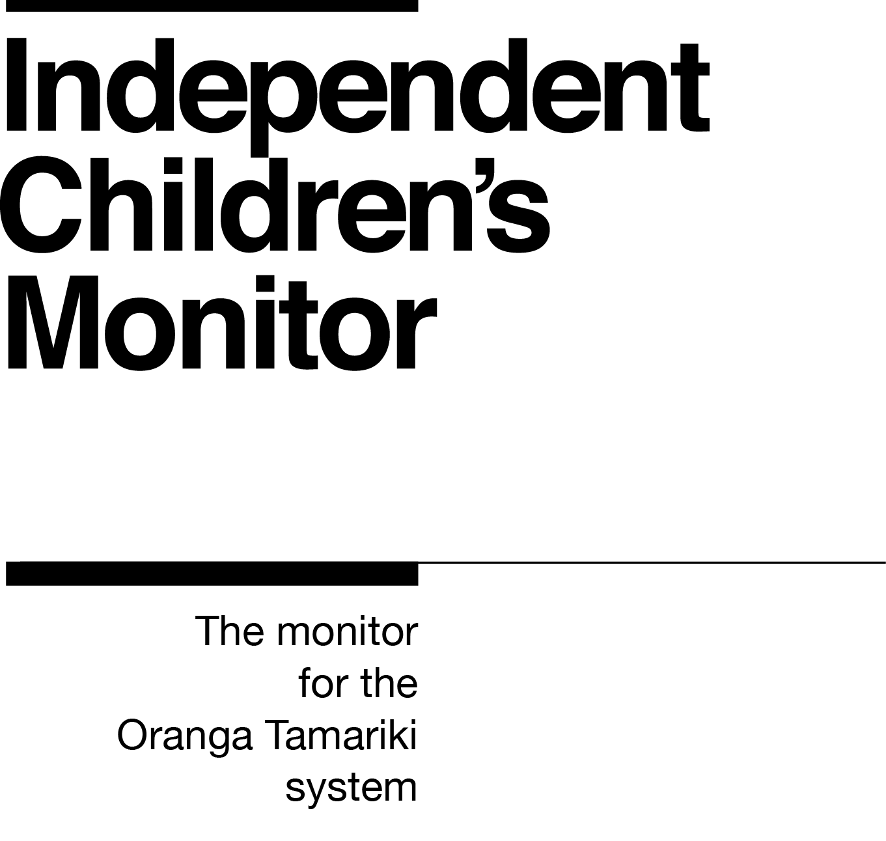

Kai Tohutohu Aroturuki/
Kai Tohutohu Matua Aroturuki
Advisor/Senior Advisor Monitoring

Our purpose
The purpose of the Independent Children’s Monitor (the Monitor) is to provide a credible view of the Oranga Tamariki System, highlighting areas that will drive continuous improvement and improve outcomes for children and young people, particularly tamariki Māori.

How we do this
The Monitor has oversight of the Oranga Tamariki System and its work will reflect the broad spectrum of monitoring from compliance, to practice quality, through to outcomes. Monitoring each of these interrelated areas enables us to assess if outcomes are being achieved for tamariki (children) and rangatahi (young people). Our review, analysis and reporting functions drive improvement and give us the opportunity to provide accurate information to a range of audiences including Ministers, government agencies, iwi, non-government agencies, whānau and individuals on the performance of the System.
We strive to always work in a way that is child-centred, embeds te ao Māori, is insight-driven and builds on our reputation as a trusted and credible influencer.
Our values
Our values have been developed within the context of our work and reflect our principles of being child centred with a te ao Māori lens across all that we do. Our values are how we behave every day, with each other and with those we are working with.

Kia Māia – Courageous: We are brave, bold, capable and confident.
Kia Pono, Kia Tika – Trustworthy: We are honest and genuine.
Manaaki – Respectful: We show respect and care for others.
Kia Huritao – to be Reflective: We are considered and reflective.

Our commitment to Māori
As a Te Tiriti o Waitangi partner we are committed to supporting and enabling Māori,
whānau, hapū, iwi and communities to realise their own potential and aspirations.
Position detail
Overview of position
The Kai Tohutohu Aroturuki/Kai Tohutohu Matua Aroturuki – Advisor/Senior Advisor Monitoring are part of the Monitoring team and are the public face of the Monitor. They and spend most of their time working in small groups conducting monitoring visits, interviews and other monitoring activities. They work closely with the Principal Advisors, Practice Leads and other Advisors to contribute to the regular cycle of reports that are the Monitor’s key output.
The Senior Advisor Monitoring takes a lead role for site visits and other monitoring activities and are responsible for writing site reports and following-up actions. They have a responsibility to less experienced team members to provide professional support and guidance and will peer review and provide quality assurance of documentation.
The Kai Tohutohu Aroturuki/Kai Tohutohu Matua Aroturuki will work in a way that reflects our commitment to a child-centred and te ao Māori focus, with particular regard for mana tamaiti.
Location
Wellington, Auckland, remote (regionally based with a reporting line to Wellington or Auckland)
Reports to
Kaiwhakahaere Aroturuki – Manager Monitoring

Key responsibilities
Monitoring
- Understanding the team’s work programme, timelines and responsibilities.
- Working with the team to identify key stakeholders for each monitoring activity and considering options and approaches to each.
- Monitoring policies and practices against the Oranga Tamariki National Care Standards, specific outcomes for Maori, specific outcomes for children with disabilities, and with particular reference to 7AA of the Oranga Tamariki Act. This monitoring will expand to the wider Oranga Tamariki System over time.
- Working in small groups to conduct monitoring visits, interviews and other monitoring activities.
- Recording all relevant information from monitoring activities on Monitor templates and ensuring secure and appropriate storage of information.
- Participating in deep dive investigations as required.
In addition, the Senior Advisor Monitoring will be:
- Leading site visits, interviews and other monitoring activities (Senior Advisor).
- Drafting site reports, coordinating follow up actions and updating the actions register (Senior Advisor).

Providing accurate and timely documentation and reports
- Validating information gathered through monitoring activities.
- Supporting the Principal Advisor Monitoring with a summary of monitoring engagements, high-level analysis of information, identifying key themes, insights and patterns.
- Contributing to reports and ad hoc documents including responses to enquiries and findings as required.
- Recording all relevant information from monitoring activities on Monitor templates and ensuring secure and appropriate storage of information.
In addition, the Senior Advisor Monitoring will be:
- Undertaking peer review and quality assurance processes (Senior Advisor).
Building capability
- Working with the team, Principal Advisor Monitoring and Manager Monitoring to maintain and regularly review processes and practices to ensure they align with the intent of overarching frameworks and methodologies.
- Maintaining and building personal professional expertise and employing best practice methodologies.
- Participating in healthy self-management and wellbeing practices.
In addition, the Senior Advisor Monitoring will be:
- Providing professional support and guidance to less experienced members of the monitoring team (Senior Advisor).
Building trusting and professional relationships
- Participating in opportunities to partner with other organisations and services to improve the function of the Monitor.
- Building experience, knowledge, skills and capabilities to confidently engage with tamariki, rangatahi, whānau and families.
- Maintaining the balance of strong affiliative, respectful relationships without compromising professional boundaries.
Embedding child-centred practice
- Building knowledge, experience and capability in child-centred practice to confidently engage with tamariki and their whānau.
- Understanding the importance of child-centred practice and supporting the Monitor to embed children’s participation and the voice of tamariki into all aspects of the Monitor’s work.
Embedding Te Ao Māori
- Building knowledge, experience, capability and understanding of tikanga Māori and te reo to confidently engage with whānau, hapū and iwi.
- Embedding te ao Māori into the status quo of the Monitor.
- Seeking advice and using empathy and judgement to adapt to the context and circumstances.
- Learning about and respecting cultural similarities and differences and appreciating diversity.
Health, Safety and Security
- Understanding and implementing Health, Safety and Security (HSS) accountabilities as outlined in the HSS Accountability Framework.
- Ensuring all health, safety and security and wellbeing policies and procedures are understood, followed and implemented.
Emergency Management and Business Continuity
- Remaining familiar with the relevant provisions of the Emergency Management and Business Continuity Plans that impact the Monitor.
- Participating in periodic training, reviews and tests of the established Business Continuity Plans and operating procedures.
Other duties as required such as special project work or attending external events.

Know-how
Interview and engagement techniques – knowledge of appropriate techniques and tools to help understand a range of people’s experiences and outcomes.
Relationship management – the ability to make meaningful connections with a wide range of people and organisations, one-on-one and collectively, and build lasting professional relationships.
Writing skills –proven ability to write clear, concise site reports, memos and other professional documents.
Analytical thinking – experience of considering a range of qualitative and quantitative data to support professional decisions.
Child focus – knowledge of child development and/or the child protection system in New Zealand; or transferable skills and experience of working with children and young people.
Cultural competency –experience of working effectively with Māori, Pasifika and other cultures.
Legislation and statutory obligations – proven ability to build knowledge of relevant statutory and public service processes.
Tertiary qualification in a relevant discipline with a professional practice background such as social work, teaching, psychology, medicine/nursing, legal etc. or evidence of equivalent relevant experience.
Group facilitation –experience of successfully facilitating groups and an understanding of group dynamics (Senior Advisor)

Attributes

- Relational
- Resilient
- Growth mindset
- Respectful
- Trustworthy

Key Relationships
Internal
- Independent Children’s Monitor colleagues
- Ministry of Social Development colleagues
External
- Oranga Tamariki site employees
- NGO provider employees
- Office of the Children’s Commissioner employees
- Māori provider employees
- Other government agency colleagues
- Hapu, iwi, whanau, rangatahi (young people), tamariki (children) and families
- Foster parents and caregivers

Other
Delegations
Financial – No
Human Resources – No
People – No
Direct reports – No
Security clearance – Yes
Children’s worker – Yes – non-core
Ability to travel regularly.
May require after-hours work.
Full drivers’ licence

