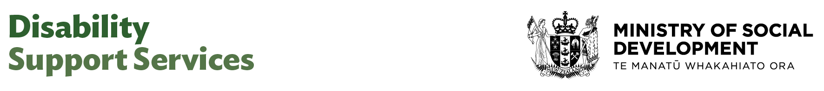

Contract Analyst

Our purpose
Manaaki tangata, Manaaki whānau
We help New Zealanders to be safe, strong and independent

Our commitment to Māori
As a Te Tiriti o Waitangi partner we are committed to supporting and enabling Māori, whānau, hapū, Iwi and communities to realise their own potential and aspirations.

Our strategic direction
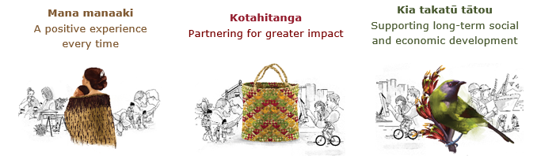

Our Values
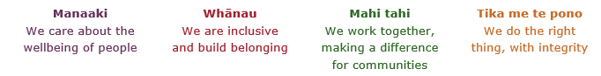

Working in the Public Service
Ka mahitahi mātou o te ratonga tūmatanui kia hei painga mō ngā tāngata o Aotearoa i āianei, ā, hei ngā rā ki tua hoki. He kawenga tino whaitake tā mātou hei tautoko i te Karauna i runga i āna hononga ki a ngāi Māori i raro i te Tiriti o Waitangi. Ka tautoko mātou i te kāwanatanga manapori. Ka whakakotahingia mātou e te wairua whakarato ki ō mātou hapori, ā, e arahina ana mātou e ngā mātāpono me ngā tikanga matua o te ratonga tūmatanui i roto i ā mātou mahi.
In the public service we work collectively to make a meaningful difference for New Zealanders now and in the future. We have an important role in supporting the Crown in its relationships with Māori under the Treaty of Waitangi. We support democratic government. We are unified by a spirit of service to our communities and guided by the core principles and values of the public service in our work.

The outcomes we want to achieve
New Zealanders get the support they require | New Zealanders are resilient and live in inclusive and supportive communities | New Zealanders participate positively in society and reach their potential

We carry out a broad range of responsibilities and functions including
- Employment, income support and superannuation
- Community partnerships, programmes and campaigns
- Advocacy for seniors, disabled people and youth
- Public Housing assistance and emergency housing
- Resolving claims of abuse and neglect in state care
- Student allowances and loans

He whakataukī*
Unuhia te rito o te harakeke  Kei hea te kōmako e kō?  Whakatairangitia, rere ki uta, rere ki tai;  Ui mai ki ahau,  He aha te mea nui o te ao?  Māku e kī atu,  He tangata, he tangata, he tangata* | If you remove the central shoot of the flaxbush  Where will the bellbird find rest?  Will it fly inland, fly out to sea, or fly aimlessly;  If you were to ask me,  What is the most important thing in the world?  I will tell you,  It is people, it is people, it is people
* We would like to acknowledge Te Rūnanga Nui o Te Aupōuri Trust for their permission to use this whakataukī

Position detail

Overview of position
The Contract Analyst provides analytical support in to contract management activities. This role ensures contract documentation is accurate and up to date, supports effective contract monitoring and compliance, and assists contract managers in delivering high-quality, value-driven services.

This role also plays a key part in supporting provider data analysis, helps identify trends and contributes to improving process that assist with contract management decisions.

DSS is focussed on achieving improved outcomes for disabled people as a commissioner, funder and steward.

Location
Various

Reports to
Manager Contracts and Funding

Key responsibilities
- Support contract monitoring by tracking key milestones, deliverables, compliance requirements, and assisting with performance reporting.
- Provide data analysis as requested to manager to identify trends, risks, and opportunities across contracts. This includes analysing funding data and developing reports to inform contract managers.
- Offer support on a range of contracts as requested
- Prepare, update, and maintain contract documentation and records, ensuring accuracy, completeness, and compliance with organisational policies and audit requirements.
- Support the preparation and execution of contract audits and reviews, ensuring all required information and documentation is readily available.
- Contribute to the development and improvement of contract management processes, systems, and templates.
- Assist Contract Managers with a range of business processes and tasks, including meeting coordination, correspondence, document preparation, and issue resolution.
- Liaise with internal teams and external providers to gather information, clarify requirements, and ensure smooth contract administration across DSS.
- Maintain confidentiality and data security when handling sensitive contract and provider information.
- Support the identification of contract risks
- Respond promptly to queries from contract managers, providers, and stakeholders, providing accurate and helpful information.
- Support training and onboarding activities for new team members or providers, as required.

Embedding te ao Māori
- Embedding Te Ao Māori (te reo Māori, tikanga, kawa, Te Tiriti o Waitangi) into the way we do things at MSD.
- Building more experience, knowledge, skills and capabilities to confidently engage with whānau, hapū and iwi.

Health, safety and security
- Understand and implement your Health, Safety and Security (HSS) accountabilities as outlined in the HSS Accountability Framework.
- Ensure you understand, follow and implement all Health, Safety and Security and wellbeing policies and procedures.

Emergency management and business continuity
- Remain familiar with the relevant provisions of the Emergency Management and Business Continuity Plans that impact your business group/team.
- Participate in periodic training, reviews and tests of the established Business Continuity Plans and operating procedures.

Know-how
- Relevant tertiary qualification and or equivalent experience
- Basic understanding of commissioning, procurement or contracts.
- Basic understanding of contracts and data analysis techniques.
- Strong organisational skills, with the ability to manage multiple tasks, priorities, and deadlines efficiently.
- Proficient analytical skills, with experience in extracting, interpreting, and reporting on data to support managers.
- High attention to detail and accuracy in all aspects of record-keeping, documentation, and reporting.
- Effective written and verbal communication skills, with the ability to work collaboratively in a team environment.
- Proficiency with IT systems, including contract management software, spreadsheets, and reporting tools.
- Ability to handle confidential information with discretion and professionalism.
- Flexible and adaptable, able to respond to changing priorities and requirements.
- Commitment to continuous improvement and supporting best practice in contract management.
- Experience working in disability sector would be benficial.

Attributes
- Highly organised and manages competing priorities well.
- Detail-focused and ensures accuracy in all work.
- Analytical and able to draw insights from data.
- Communicates clearly and works collaboratively with others.
- Proactive in supporting the team and resolving issues.
- Handles sensitive information with discretion.
- Flexible and adapts quickly to changing needs.
- Reliable, accountable, and committed to high standards.

Key relationships

Internal
- Commissioning Managers
- Contract Managers
- Commissioning Team administration
- Commissioning Leads
- Commissioning Principal Advisor
- Commissioning Senior Advisor
- Commissioning Senior Project Coordinator
- Commissioning Business Analyst
- Director Commissioning
- General Manager, Commissioning, Funding

External
- Other Government Agencies
- Third party commissioned providers
- Disabled communities

Other

Delegations
- Financial – No
- Human Resources - No

Direct reports - No

Security clearance - No

Children’s worker - No
Limited adhoc travel may be required

Position Description Updated: June 2025

