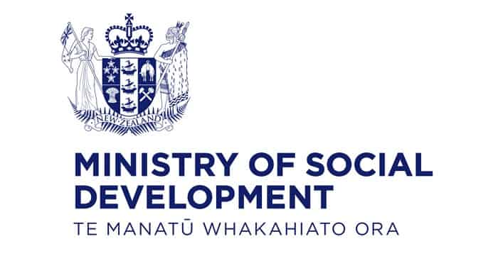

Developer – Improvement Systems and Technology

About MSD

Our purpose
Manaaki tangata, Manaaki whānau
We help New Zealanders to be safe, strong, and independent.

Our commitment to Māori
As a Te Tiriti o Waitangi partner we are committed to supporting and enabling Māori, whānau, hapū, Iwi and communities to realise their own potential and aspirations.

Our strategic direction
Mana manaaki  A positive experience every time   | Kotahitanga  Partnering for greater impact   | Kia takatū tatou  Supporting long-term social and economic development  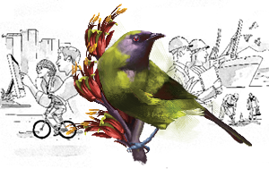

Our Values
Manaaki  We care about the wellbeing of people | Whānau  We are inclusive and build belonging | Mahi tahi  We work together, making a difference for communities | Tika me te pono  We do the right thing, with integrity

Working in public service
Ka mahitahi mātou o te ratonga tūmatanui kia hei painga mō ngā tāngata o Aotearoa i āianei, ā, hei ngā rā ki tua hoki. He kawenga tino whaitake tā mātou hei tautoko i te Karauna i runga i āna hononga ki a ngāi Māori i raro i te Tiriti o Waitangi. Ka tautoko mātou i te kāwanatanga manapori. Ka whakakotahingia mātou e te wairua whakarato ki ō mātou hapori, ā, e arahina ana mātou e ngā mātāpono me ngā tikanga matua o te ratonga tūmatanui i roto i ā mātou mahi.
In the public service we work collectively to make a meaningful difference for New Zealanders now and in the future. We have an important role in supporting the Crown in its relationships with Māori under the Treaty of Waitangi. We support democratic government. We are unified by a spirit of service to our communities and guided by the core principles and values of the public service in our work potential and aspirations.

The outcomes we want to achieve
- New Zealanders get the support they require
- New Zealanders are resilient and live in inclusive and supportive communities
- New Zealanders participate positively in society and reach their potential

We carry out a range of responsibilities and functions including
- Employment, income support and superannuation
- Community partnerships, programmes, and campaigns
- Advocacy for seniors, disabled people, and youth
- Public housing assistance and emergency housing
- Resolving claims of abuse and neglect in state care
- Student allowances and loans

He Whakataukī*
Unuhia te rito o te harakeke | If you remove the central shoot of the flaxbush
Kei hea te kōmako e kō? | Where will the bellbird find rest?
Whakatairangitia, rere ki uta, rere ki tai; | Will it fly inland, fly out to sea, or fly aimlessly;
Ui mai ki ahau, | If you were to ask me,
He aha te mea nui o te ao? | What is the most important thing in the world?
Māku e kī atu, | I will tell you,
He tangata, he tangata, he tangata* | It is people, it is people, it is people
*We would like to acknowledge Te Rūnanga Nui o Te Aupōuri Trust for their permission to use this whakataukī.

Position Detail

Overview of position
The Developer provides software development within a highly integrated environment. They work with a range of business and technical teams to design, build and deploy software. They work on legacy and contemporary software throughout the entire development lifecycle. They work within established practices and protocols in an enterprise environment.

Location
National Office, Wellington or Auckland

Reports to
Technology People Leader

Key responsibilities

Required skills

Programming/software development (PROG) Level 3
Developing software components to deliver value to stakeholders.
- Designs, codes, verifies, tests, documents, amends and refactors moderately complex programs/scripts.
- Applies agreed standards and tools to achieve a well-engineered result.
- Monitors and reports on progress.
- Identifies issues related to software development activities.
- Proposes practical solutions to resolve issues.
- Collaborates in reviews of work with others as appropriate.

Software design (SWDN) Level 3
Specifying and designing software to meet defined requirements by following agreed design standards and principles.
- Undertakes complete design of moderately complex software applications or components.
- Applies agreed standards, guidelines, patterns and tools. Assists as part of a team in the design of components of larger software systems.
- Specifies user and/or system interfaces.
- Creates multiple design views to address the different stakeholders' concerns and to handle functional and non-functional requirements.
- Assists in the evaluation of options and trade-offs.
- Collaborates in reviews of work with others as appropriate.

Application support (ASUP) Level 3
Delivering management, technical and administrative services to support and maintain live applications.
- Follows agreed procedures to identify and resolve issues with applications.
- Uses application management software and tools to collect agreed performance statistics.
- Carries out agreed applications maintenance tasks.
Problem management (PBMG) Level 3
Managing the life cycle of all problems that have occurred or could occur in delivering a service.
- Investigates problems in systems, processes and services.
- Assists with the implementation of agreed remedies and preventative measures.

Desirable skills

Systems design (DESN) Level 3
Designing systems to meet specified requirements and agreed systems architectures.
- Follows standard approaches and established design patterns to create new designs for simple systems or system components.
- Identifies and resolves minor design issues.
- Identifies alternative design options and seeks guidance when deviating from established design patterns.

Software configuration (PORT) Level 3
Designing and deploying software product configurations into software environments or platforms.
- Assists in designing, verifying, documenting, amending and refactoring moderately complex software configurations for deployment.
- Applies agreed standards and tools, to achieve a well-engineered result.
- Collaborates in reviews of work with others as appropriate.

User experience evaluation (USEV) Level 2
Validating systems, products or services against user experience goals, metrics and targets.
- Assists in preparing and operating the environment, facilities and tools needed to evaluate systems, products, services or devices.
- Assists in the collection of feedback on prototypes and designs from users and others.

Data modelling and design (DTAN) Level 2
Developing models and diagrams to represent and communicate data requirements and data assets.
- Establishes, modifies or maintains simple data structures and associated components.
- Uses specific data modelling and design techniques under guidance.

Levels of responsibility

Autonomy – Level 3
- Works under general direction.
- Receives specific direction, accepts guidance and has work reviewed at agreed milestones.
- Uses discretion in identifying and responding to complex issues related to own assignments.
- Determines when issues should be escalated to a higher level.
- Plans and monitors own work (and that of others where applicable) competently within limited deadlines.

Influence – Level 3
- Interacts with and influences colleagues.
- May oversee others or make decisions which impact routine work assigned to individuals or stages of projects.
- Has working level contact with customers, suppliers and partners.
- Understands and collaborates on the analysis of user/customer needs and represents this in their work.
- Contributes fully to the work of teams by appreciating how own role relates to other roles.

Complexity – Level 3
- Performs a range of work, sometimes complex and non-routine, in a variety of environments.
- Applies a methodical approach to routine and moderately complex issue definition and resolution.
- Applies and contributes to creative thinking or finds new ways to complete tasks.

Business skills – Level 3
- Demonstrates effective oral and written communication skills when engaging on issues with colleagues, users/customers, suppliers and partners.
- Understands and effectively applies appropriate methods, tools, applications and processes.
- Demonstrates judgement and a systematic approach to work.
- Effectively applies digital skills and explores these capabilities for their role.
- Learning and professional development — takes the initiative to develop own knowledge and skills by identifying and negotiating appropriate development opportunities.
- Security, privacy and ethics — demonstrates appropriate working practices and knowledge in non-routine work. Appreciates how own role and others support appropriate working practices.

Knowledge – Level 3
- Has sound generic, domain and specialist knowledge necessary to perform effectively in the organisation typically gained from recognised bodies of knowledge and organisational information.
- Has an appreciation of the wider business context.
- Demonstrates effective application and the ability to impart knowledge found in industry bodies of knowledge.
- Absorbs new information and applies it effectively.

Embedding Te Ao Māori
- Embedding Te Ao Māori (te reo Māori, tikanga, kawa, Te Tiriti o Waitangi) into the way we do things at MSD.
- Building more experience, knowledge, skills and capabilities to confidently engage with whānau, hapū and iwi.

Health, Safety and Security
- Understand and implement your Health, Safety and Security (HSS) accountabilities as outlined in the HSS Accountability Framework.
- Ensure you understand, follow and implement all Health, Safety and Security and wellbeing policies and procedures.

Emergency Management and Business Continuity
- Remain familiar with the relevant provisions of the Emergency Management and Business Continuity Plans that impact your business group/team.
- Participate in periodic training, reviews and tests of the established Business Continuity Plans and operating procedures.

Know-how
- Tertiary qualification in Computer Science or Information Technology (or equivalent professional experience)
- Understanding of enterprise level software development practices (large complex environment), including the use of source control repositories, peer review practices, and change/release processes
- Knowledge of contemporary software development methods and best practice processes for the appropriate operating systems, e.g., Window, MacOS, Linux.
- Understanding of technology solutions within complex business environments
- Capability using current business systems modelling tools
- Familiar with working in an Agile / Scaled Agile work environment
- Familiar with DevOps practices and iterative development
- Appreciation of automated testing and working with continuous integration / continuous deployment

Key relationships

Internal
- Development Practice
- Business Stakeholders
- Testers and Technical Business Analysts
- Other IST and Ministry Staff

External
- Vendors

Other

Delegations
- Financial – No
- Human Resources – No

Direct reports
- No

Security clearance
- No

Children’s worker
- Not a children’s worker

Travel
- Limited adhoc travel may be required

