# Ministry of Social Development logo

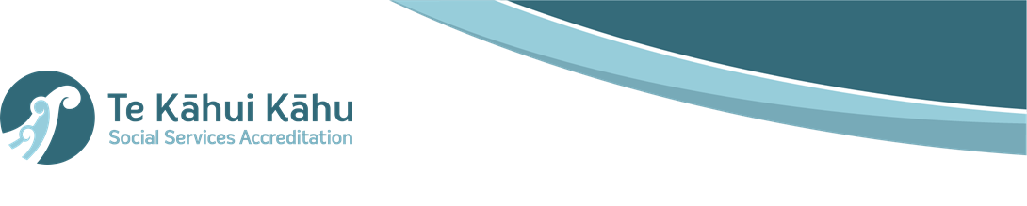

# System Administrator

# Te Kāhui Kāhu

## Our purpose

**Manaaki tangata, Manaaki whānau**

We help New Zealanders to be safe, strong and independent

## Our commitment to Māori

As a **Te Tiriti o Waitangi** partner we are committed to supporting and enabling Māori, whānau, hapū, Iwi and communities to realise their own potential and aspirations.

## Our strategic direction

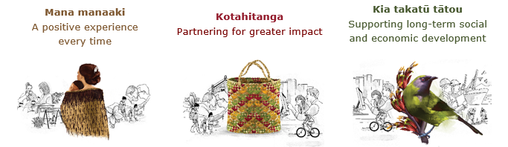

## Our Values

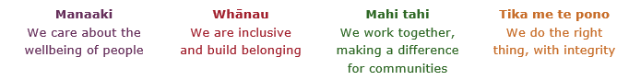

## Working in the Public Service

Ka mahitahi mātou o te ratonga tūmatanui kia hei painga mō ngā tāngata o Aotearoa i āianei, ā, hei ngā rā ki tua hoki. He kawenga tino whaitake tā mātou hei tautoko i te Karauna i runga i āna hononga ki a ngāi Māori i raro i te Tiriti o Waitangi. Ka tautoko mātou i te kāwanatanga manapori. Ka whakakotahingia mātou e te wairua whakarato ki ō mātou hapori, ā, e arahina ana mātou e ngā mātāpono me ngā tikanga matua o te ratonga tūmatanui i roto i ā mātou mahi.

In the public service we work collectively to make a meaningful difference for New Zealanders now and in the future. We have an important role in supporting the Crown in its relationships with Māori under the Treaty of Waitangi.  We support democratic government. We are unified by a spirit of service to our communities and guided by the core principles and values of the public service in our work.

## The outcomes we want to achieve

|  |  |  |
| --- | --- | --- |
| New Zealanders get the support they require | New Zealanders are resilient and live in inclusive and supportive communities | New Zealanders participate positively in society and reach their potential |

## We carry out a broad range of responsibilities and functions including

* Employment, income support and superannuation
* Community partnerships, programmes and campaigns
* Advocacy for seniors, disabled people and youth
* Public Housing assistance and emergency housing
* Resolving claims of abuse and neglect in state care
* Student allowances and loans

## **He whakataukī\***

|  |  |
| --- | --- |
| Unuhia te rito o te harakeke  Kei hea te kōmako e kō?  Whakatairangitia, rere ki uta, rere ki tai;  Ui mai ki ahau,  He aha te mea nui o te ao?  Māku e kī atu,  He tangata, he tangata, he tangata* | If you remove the central shoot of the flaxbush  Where will the bellbird find rest?  Will it fly inland, fly out to sea, or fly aimlessly;  If you were to ask me,  What is the most important thing in the world?  I will tell you,  It is people, it is people, it is people |

* We would like to acknowledge Te Rūnanga Nui o Te Aupōuri Trust for their permission to use this whakataukī

## Position detail

### Overview of position

Te Kāhui Kāhu is a unit within the Ministry of Social Development providing accreditation services across the social sector. We are a nationwide team that provides Government and communities with the independent assurance that social sector providers have the capacity to deliver safe, quality services to New Zealanders. We do this by working with social service providers to ensure they meet the Social Services Accreditation Standards.

Our team provides a professional accreditation service on behalf of seven Government Agencies, for approximately 2,000 social service providers/organisations. We have our own advisory Board and charge for our services.

We also provide bespoke services outside core accreditation for other agencies. This includes Core Worker Exemptions, Pay Equity Oversight, Provider capability support, Non-Registered Social Work compliance, and other services that are delivered on a fully funded basis outside the fees-based Accreditation service.

### Location

This position is based in Wellington.

### Reports to

Programme Manager, Te Kāhui Kāhu

## Key responsibilities

Te Kāhui Kāhu commenced the transition to a Salesforce platform in June 2022. The platform is being deployed across multiple system development phases. The first phase was fully launched in September 2022 and involved our end to end, standard accreditation process. A second phase is underway and this is expected to go live from late May to early June 2023. Phase 2 will capture non-standard, out of cycle work and business processes. A third phase is planned for 2024.

The system administrator will be responsible for:

• Triage technical and practice support requests and action appropriately

• Provide technical system support to ensure satisfaction of internal and external users in their use of our new Salesforce platform

• Support the wider team with system and technical support, as required

• Support system continuous improvement

• Support the development and implementation of project phases, as required

• Support the Programme Manager in management and prioritization of issues.

### Frontline support

• Triage incoming system enquires and issues including identifying the size and complexity of new issues.

• Fully support social service providers and internal staff with technical queries and concerns.

• Investigate and problem solve user issues.

* Resolve Level 1 system issues
* For Level 2 and above discuss with Senior Analyst or with 3rd party vendor for resolution support & ensure issue is resolved
* Provide regular reports on system issues and resolutions to manager

• Assist with the development or resources and training for end-users.

### System Administration

• On-boarding and off-boarding users, and providing access support to new and existing users

• Manage information archiving and back-ups for the system

• Troubleshoot issues and outages

• Identify production risks and areas for improvement (priorities/designs) and support successful implementation and adoption of new processes

• Support requirement gathering for system enhancements and work with the team to propose solutions that leverage Salesforce functionality

• Support installation and configuration changes of the system, as required

• Support with user training and functional testing for small and continuous improvements where needed

• Create and maintain system processes and documentation for the system

• Ensure best practices are followed with regards to system maintenance and data integrity

• Ensure security levels are met through access controls, backups, and plans are in place for disaster recovery

### Reporting and analytics

• Ensure data is accurate and available to the internal and external stakeholders in the preferred format, as required

• Identify opportunities to provide analysis and trends to inform future business decisions

### Relationship Management

• Represent Te Kāhui Kāhu as required

• Build and maintain strong internal and external stakeholder relationships

## Embedding te ao Māori

* Embedding Te Ao Māori (te reo Māori, tikanga, kawa, Te Tiriti o Waitangi) into the way we do things at MSD.
* Building more experience, knowledge, skills and capabilities to confidently engage with whānau, hapū and iwi.

## Health, safety and security

* Understand and implement your Health, Safety and Security (HSS) accountabilities as outlined in the HSS Accountability Framework.
* Ensure you understand, follow and implement all Health, Safety and Security and wellbeing policies and procedures.

## Emergency management and business continuity

* Remain familiar with the relevant provisions of the Emergency Management and Business Continuity Plans that impact your business group/team.
* Participate in periodic training, reviews and tests of the established Business Continuity Plans and operating procedures.

## Know-how

• Salesforce Administration Certification

• Experienced system administrator with salesforce knowledge

• Able to generate reports and dashboards in salesforce as required

• Experience with UAT, user training and system updates, user administration and licensing.

• Ability to identify areas for process improvement and recommend/implement solutions

• Strong understanding of data structures and data modelling. Experience with Dataloader or Dataloader.io an advantage

• Meticulous attention to data quality

• Comfortable with the use of the Microsoft Business Suite and collaboration tools.

• Experience working in an Agile Framework (Scrum or Kanban) preferred.

## Attributes

* Excellent communication skills (oral and written)
* Strong customer focus
* Ability to build and maintain effective working relationships through active engagement
* Proven creativity and problem-solving skills; ability to work around obstacles and solve problems with minimal direction.
* Able to adapt, demonstrate initiative, and cope with continuing change
* Strong ability to work in a team environment – able to work to support individual as well as team objectives/ goals
* Strong organisational/time management skills; ability to prioritise work and meet deadlines in a fast-paced environment.
* Welcomes and values diversity and contributes to an inclusive working environment where differences are acknowledged and respected.

## Key relationships

### Internal

* Tiaki online project team
* General Manager Te Kāhui Kāhui and wider business unit

### External

* Social sector providers

## Other

### Delegations

* Financial – No
* Human Resources – No

### Direct reports: No

### Security clearance: No

### Children’s worker: No

Limited adhoc travel may be required

**Position Description Updated:**  February 2023