

Training Coordinator, Learning and Capability

People Group

Our purpose
Manaaki tangata, Manaaki whānau
We help New Zealanders to be safe, strong and independent

Our commitment to Māori
As a Te Tiriti o Waitangi partner we are committed to supporting and enabling Māori, whānau, hapū, Iwi and communities to realise their own potential and aspirations.

Our strategic direction
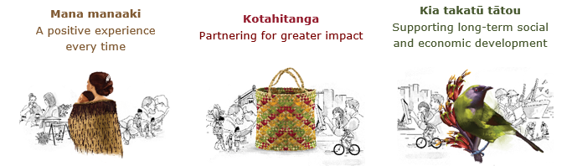

Our Values
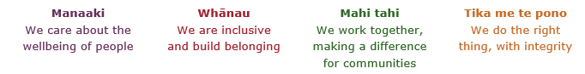

Working in the Public Service
Ka mahitahi mātou o te ratonga tūmatanui kia hei painga mō ngā tāngata o Aotearoa i āianei, ā, hei ngā rā ki tua hoki. He kawenga tino whaitake tā mātou hei tautoko i te Karauna i runga i āna hononga ki a ngāi Māori i raro i te Tiriti o Waitangi. Ka tautoko mātou i te kāwanatanga manapori. Ka whakakotahingia mātou e te wairua whakarato ki ō mātou hapori, ā, e arahina ana mātou e ngā mātāpono me ngā tikanga matua o te ratonga tūmatanui i roto i ā mātou mahi.
In the public service we work collectively to make a meaningful difference for New Zealanders now and in the future. We have an important role in supporting the Crown in its relationships with Māori under the Treaty of Waitangi. We support democratic government. We are unified by a spirit of service to our communities and guided by the core principles and values of the public service in our work.

The outcomes we want to achieve
New Zealanders get the support they require | New Zealanders are resilient and live in inclusive and supportive communities | New Zealanders participate positively in society and reach their potential

We carry out a broad range of responsibilities and functions including
- Employment, income support and superannuation
- Community partnerships, programmes and campaigns
- Advocacy for seniors, disabled people and youth
- Public Housing assistance and emergency housing
- Resolving claims of abuse and neglect in state care
- Student allowances and loans

He whakataukī*
Unuhia te rito o te harakeke  Kei hea te kōmako e kō?  Whakatairangitia, rere ki uta, rere ki tai;  Ui mai ki ahau,  He aha te mea nui o te ao?  Māku e kī atu,  He tangata, he tangata, he tangata* | If you remove the central shoot of the flaxbush  Where will the bellbird find rest?  Will it fly inland, fly out to sea, or fly aimlessly;  If you were to ask me,  What is the most important thing in the world?  I will tell you,  It is people, it is people, it is people
* We would like to acknowledge Te Rūnanga Nui o Te Aupōuri Trust for their permission to use this whakataukī

Position detail

Overview of position
The purpose of the Training Coordinator, Learning and Capability is to support users of the Learning Management systems, tools and products, and to work with other trainers to deploy new learning and update existing learning.
The Training Coordinator is responsible for supporting the implementation of training strategies and solutions that deliver enhanced business capability, including:
- Assisting in the deployment and coordination of learning and development solutions for specified projects and activities
- Using the Ministry’s learning management system to develop reporting on training completion and evaluating training effectiveness
- Reviewing and maintaining training materials, systems and other tools and technologies
- Building relationships with and supporting the training community
- Supporting the L&C units communications and information sharing, including the management of the intranet and other tools and resources.

Location
National Office

Reports to
Manager Curriculum Design

Key responsibilities

System and technology management
- Is a subject matter expert in the systems and technologies available to the Learning and Capability Team
- Maintains systems integrity by ensuring that the information including staff learning profiles are kept up to date and are accurate
- Provides advice and support to users of the Ministry’s Learning Management System and other learning technologies

Coordination and deployment
- Supports the coordination of training deployments as required, working with key stakeholders
- Liaises with management to provide information and support on the access to learning / training and use of related technologies
- Monitors and reports on deployment , follows up with sites where scheduled learning has not been completed and implements actions to increase uptake where required
- Contributes to projects and initiatives as required
- Supports the training community to ensure effective and timely use of the learning management system and training outcomes

Evaluation
- Monitors, records, evaluates, reports and provides feedback to key stakeholders on training activities
- Contributes to monitoring and reporting on effectiveness of training activities and plans
- Ensures requirements for refresher training are tracked and implemented
- Produces reports that meet the audiences need on any aspects of training

Relationship and Stakeholder Management
- Actively collaborates with, and is a key point of contact and support for key stakeholders in relation to training needs and solutions
- Builds effective relationships with management and staff at all levels

Leadership
- Uses influencing skills to encourage stakeholders to use the learning management system effectively and efficiently
- Maintains personal and professional development to meet the changing demands of the job and participates in training and development activities where appropriate
- Keeps up to date with product knowledge, legislative changes and other core business information

Embedding te ao Māori
- Embedding Te Ao Māori (te reo Māori, tikanga, kawa, Te Tiriti o Waitangi) into the way we do things at MSD.
- Building more experience, knowledge, skills and capabilities to confidently engage with whānau, hapū and iwi.

Health, safety and security
- Understand and implement your Health, Safety and Security (HSS) accountabilities as outlined in the HSS Accountability Framework.
- Ensure you understand, follow and implement all Health, Safety and Security and wellbeing policies and procedures.

Emergency management and business continuity
- Remain familiar with the relevant provisions of the Emergency Management and Business Continuity Plans that impact your business group/team.
- Participate in periodic training, reviews and tests of the established Business Continuity Plans and operating procedures.

Know-how
- Ability to enhance and supplement training material to meet training delivery circumstances where appropriate as well as incorporating a range of training styles, methods and aids to assist the learning experience
- Ability to design and maintain learning management systems and maintain records
- Ability to use computer based office software packages such as MIS, word processing, spread sheets, presentations, including MS Word, MS Excel, and MS PowerPoint, WebEx and the use of Learning Management Systems
- Knowledge of coordinating training events, including administration

Attributes
- Exceptional communication skills – written, oral, and presentation
- High levels of client service orientation
- Creative and flexible
- Able to quickly gather and analyse information from a wide range of sources
- Self-directed
- Effective relationship and stakeholder management

Key relationships

Internal
- Trainers, managers and communications staff
- Other Learning and Capability roles particularly the Training Design Advisors and Seniors Advisors
- Other service line trainers and support staff
External
- Relationships with relevant external agencies and providers
- Other government agencies and departments as appropriate

Other

Delegations
- Financial – No
- Human Resources – No

Direct reports – No

Security clearance – No

Children’s worker – No
Limited adhoc travel may be required

Position Description Updated: August 2021

