

Team Administrator

Ministerial and Executive Services

Our purpose
Manaaki tangata, Manaaki whānau
We help New Zealanders to be safe, strong and independent

Our commitment to Māori
As a Te Tiriti o Waitangi partner we are committed to supporting and enabling Māori, whānau, hapū, Iwi and communities to realise their own potential and aspirations.

Our strategic direction
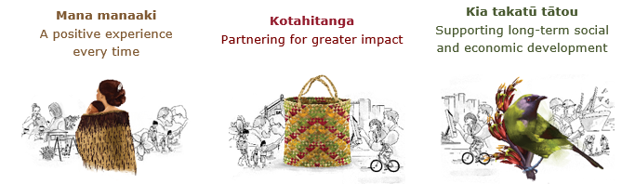

Our Values
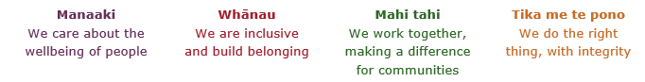

Working in the Public Service
Ka mahitahi mātou o te ratonga tūmatanui kia hei painga mō ngā tāngata o Aotearoa i āianei, ā, hei ngā rā ki tua hoki. He kawenga tino whaitake tā mātou hei tautoko i te Karauna i runga i āna hononga ki a ngāi Māori i raro i te Tiriti o Waitangi. Ka tautoko mātou i te kāwanatanga manapori. Ka whakakotahingia mātou e te wairua whakarato ki ō mātou hapori, ā, e arahina ana mātou e ngā mātāpono me ngā tikanga matua o te ratonga tūmatanui i roto i ā mātou mahi.
In the public service we work collectively to make a meaningful difference for New Zealanders now and in the future. We have an important role in supporting the Crown in its relationships with Māori under the Treaty of Waitangi. We support democratic government. We are unified by a spirit of service to our communities and guided by the core principles and values of the public service in our work.

The outcomes we want to achieve
New Zealanders get the support they require | New Zealanders are resilient and live in inclusive and supportive communities | New Zealanders participate positively in society and reach their potential

We carry out a broad range of responsibilities and functions including
- Employment, income support and superannuation
- Community partnerships, programmes and campaigns
- Advocacy for seniors, disabled people and youth
- Public Housing assistance and emergency housing
- Resolving claims of abuse and neglect in state care
- Student allowances and loans

He whakataukī*
Unuhia te rito o te harakeke  Kei hea te kōmako e kō?  Whakatairangitia, rere ki uta, rere ki tai;  Ui mai ki ahau,  He aha te mea nui o te ao?  Māku e kī atu,  He tangata, he tangata, he tangata* | If you remove the central shoot of the flaxbush  Where will the bellbird find rest?  Will it fly inland, fly out to sea, or fly aimlessly;  If you were to ask me,  What is the most important thing in the world?  I will tell you,  It is people, it is people, it is people
* We would like to acknowledge Te Rūnanga Nui o Te Aupōuri Trust for their permission to use this whakataukī

Position detail

Overview of position

The Ministerial & Executive Services (MaES) Team Administrator will provide high quality and efficient administrative support to a team within Ministerial & Executive Services.

Location

National Office

Reports to

Manager Correspondence/Official and Parliamentary Information

Key responsibilities
Administration Support
- Logs, acknowledges, sends and files correspondence, Official Information Act requests/responses, and Written Parliamentary Questions
- Prepares OIA responses for proactive release and undertakes the publishing process
- Operates all systems and procedures in such a manner as to meet Ministry requirements
- Maintains confidentiality of documentation and information as required and appropriate
- Proactively looks to implement improvement and efficiencies to current administrative processes
- Maintains and update process documents as required
MaES Information Administration and Reporting
- Maintains data documentation and preparation for workflow to produce required statistical reports
- Maintains and produces reports on Parliamentary Questions, Reports, Official Information Act requests and Chief Executive’s correspondence, independently and to the required standard
- Sets up and prepares electronic and paper files
- Enters data and information into the database to log, assign, update and track workflows
- Answers queries about Workflow and Objective enabling the team to use the systems more efficiently and effectively
Support for Projects and Ad Hoc Work
- Undertakes and implements one-off administrative related projects and initiatives
- Assists Managers with administration support such as diary management as required
- Provides other day to day general administrative support to the team such as team leave calendar as required
- Provides cover and additional administrative support to teams in the wider Ministerial and Executive Services Group as required

Correspondence, Cabinet papers and Ministerial reports
- Provide information to wider Ministry staff on processes and procedures for cabinet papers, minutes, agendas and reports to Ministers
- Liaise with key Ministry staff to ensure that their service requirements are met
- Manage info@msd and MaES Enquiries inboxes as required
- Obtain and register reports to Ministers and generate traceable references for reporting purposes
- Adopt standards and procedures as outlined by Ministry staff and Ministers’ offices

Embedding te ao Māori
- Embedding Te Ao Māori (te reo Māori, tikanga, kawa, Te Tiriti o Waitangi) into the way we do things at MSD.
- Building more experience, knowledge, skills and capabilities to confidently engage with whānau, hapū and iwi.

Health, safety and security
- Understand and implement your Health, Safety and Security (HSS) accountabilities as outlined in the HSS Accountability Framework.
- Ensure you understand, follow and implement all Health, Safety and Security and wellbeing policies and procedures.

Emergency management and business continuity
- Remain familiar with the relevant provisions of the Emergency Management and Business Continuity Plans that impact your business group/team.
- Participate in periodic training, reviews and tests of the established Business Continuity Plans and operating procedures.

Know-how
- Knowledge of/interest in government processes
- Good knowledge and experience working with standard office software products e.g. Word, Excel, Adobe and publishing tools
- Proven organisational and time management skills
- Good technical understanding of IT processes and systems
- Experience working with electronic document management systems would be advantageous

Attributes
- Excellent attention to detail – checks work for errors/omissions, keeps track of changes, assures all tasks assigned are completed.
- Strong client focus – able to establish, build and maintain sound working relationships with both internal and external stakeholders
- Good interpersonal skills – able to vary style to suit the needs of the audience
- Strong communication skills – in a variety of mediums especially written and oral
- Highly developed organisational skills – able to prioritise work, develop schedules, identify resources required and work in a systematic, structured way.
- Sound problem solving skills –considers information from a variety of sources and weighs up all relevant facts in making decisions/recommendations
- Political sensitivity
- Welcomes and values diversity, and contributes to an inclusive working environment where differences are acknowledged and respected

Key relationships

Internal
- MaES staff
- MaES Managers and the General Manager
- Managers and staff elsewhere in MSD

External
- Ministerial Office staff

Other

Delegations
- Financial – No
- Human Resources – No

Direct reports – No

Security clearance – No

Children’s worker – No
Limited adhoc travel may be required

Position Description Updated: January 2022

