Disabled children who have to live away from the family home

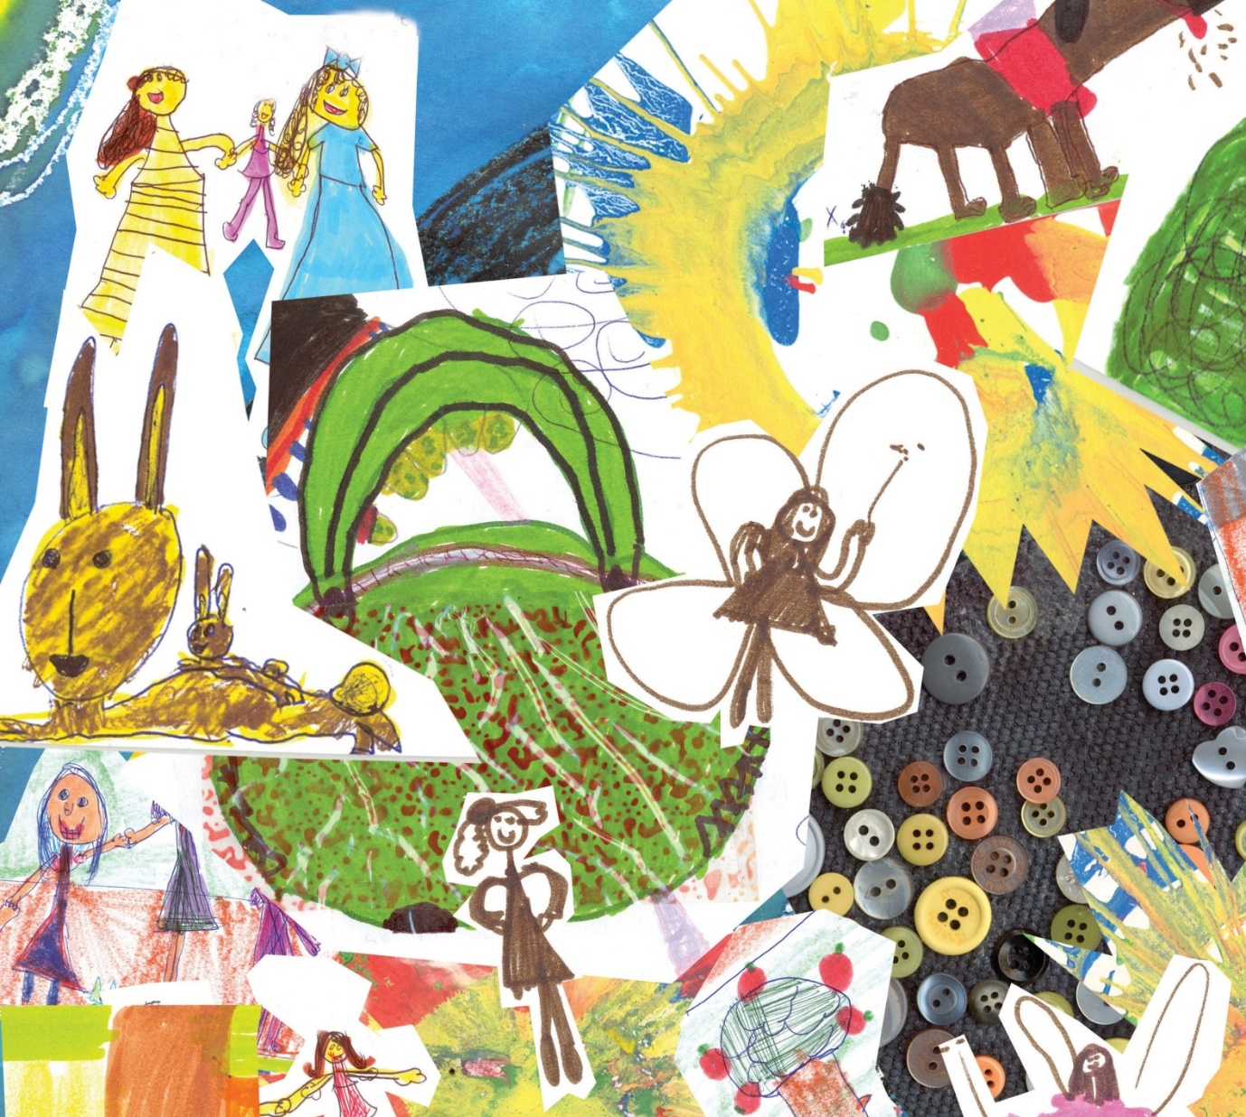

What do you think?
March 2015

Easy Read Information
This document is looking at part of a law called:

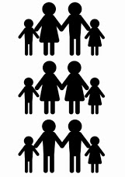
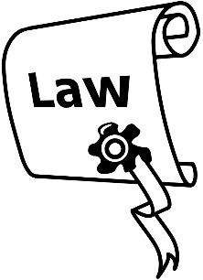
The Children, Young Persons, and Their Families Act 1989.

The part of the Act that this information is looking at and asking for feedback on is:

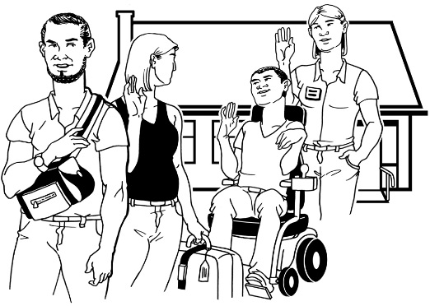
What happens when family/ whānau think it would be best for their disabled child or young person to live away from the family home.

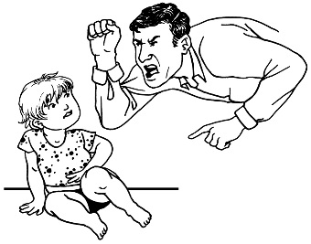
This review is not about:

- disabled children who have been abused or treated badly
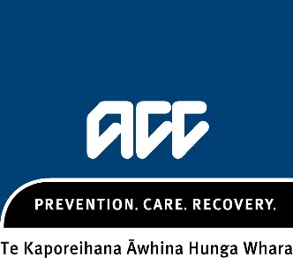
- policies or rules of ACC

- how ACC works

- policies or rules of the Ministry of Education

- how the Ministry of Education is run.

We want to know what you have to say.

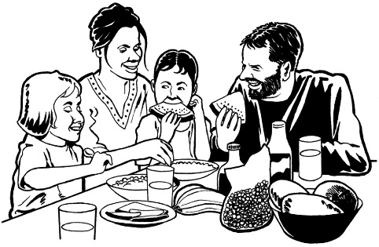
We are looking at The Children, Young Persons, and Their Families Act 1989 because we want disabled children and young people to get their rights to be:
- safe

- able to live in a family.

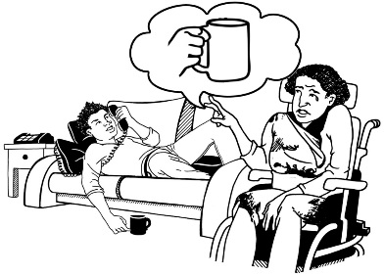
At the moment disabled children and young people are treated differently to other children and young persons.

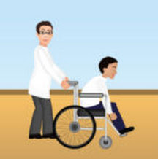
We are also looking at the support and services that disabled children and young people who have high support needs get right now.

We want to know how we can support disabled children and young people who have high support needs to keep living in their family home.

What do you think could make the lives of disabled children and young people better when they have to live away from their families in:

- foster care?

- small group homes?

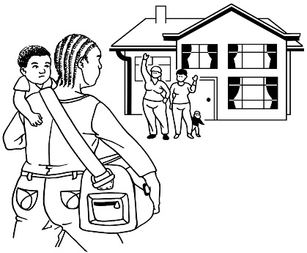

There are times when families cannot support their disabled child or young person to live in their family home.

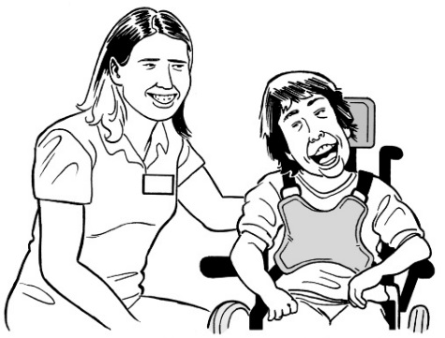
We want to have a better idea of the needs of these disabled children.

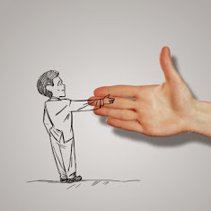
We want to know how we can support families to keep disabled children living in the family home whenever we can.

We are also looking at how we support disabled children, young people and their families when children are living away from the family home.

We want things to work well for everyone.

Information about what we are doing

The Vulnerable Children laws are new laws that were made in 2014.

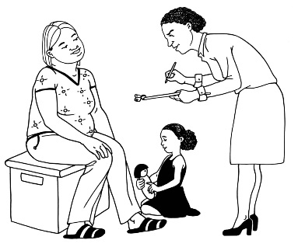
Vulnerable children means children who need the support of services to keep them well and safe.

These new laws made changes to The Children, Young Persons and Their Families Act 1989.

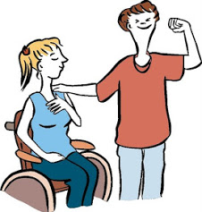
Some of these changes were made to make the lives of disabled children and young people who are living away from home better.

The changes are a good start at making changes for disabled children and young people but there is more to be done.

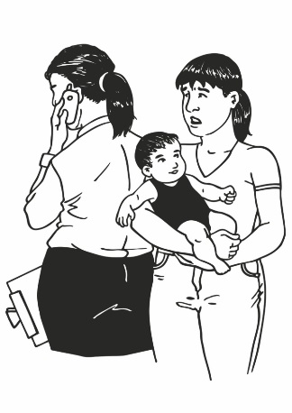

Things are not as good as they should be for disabled children, young people and their families.

That is why we are looking into things and why we are asking you for your ideas.

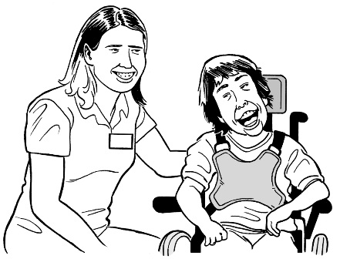
Most disabled children can be cared for and live in their family home with only a little bit of extra help.

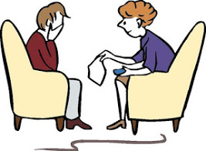
For disabled children with very high support needs it can be hard to give the right kind of care and support from within the family home.

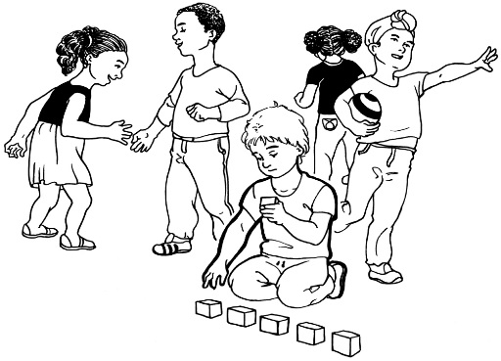

For disabled children with very high support needs it can be hard to do day to day activities.

Many families need more help to get the right day to day care for their disabled children who have very high support needs.

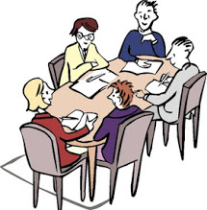
We are only looking at making changes to the system for disabled children and young people who have very high support needs.
How to have your say

You can have your say:

- from now

- until the 29th May 2015.

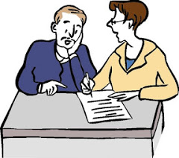
To have your say you can:
- write to us

- have a say online on the computer
- use social media sites.

You can:
- answer some of the questions

- answer all of the questions

- write about what you want to have a say on.
To have a say:

- have a say online here:
www.msd.govt.nz/disabled-children-project

- fill out the form at the end of this information and send it to us at:

The Disabled Children Project
Ministry of Social Development
PO Box 1556
Wellington 6140

- email us at:
dcp@msd.govt.nz

- post your comments on social media – check the Disabled Children Project website to see how to do this:
www.msd.govt.nz/disabled-children-project

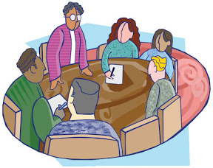
- take part in one of the Have a say events in your area. Details of these will be posted on the Disabled Children Project website:
www.msd.govt.nz/disabled-children-project

You can also call us if you want help to fill out this form:

(04) 931 2395

What will happen after you give us your feedback?

We will look at all the feedback that people have given.

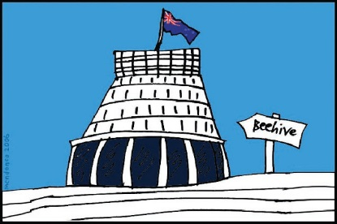
We will give advice to the Government about making changes to:

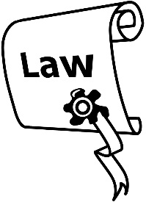
- laws

- policies or rules

- how things are done

- how people work with disabled children and their families.

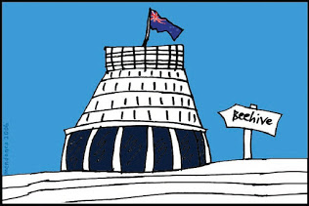
The Government will use this information to make the lives of disabled children and their families better.

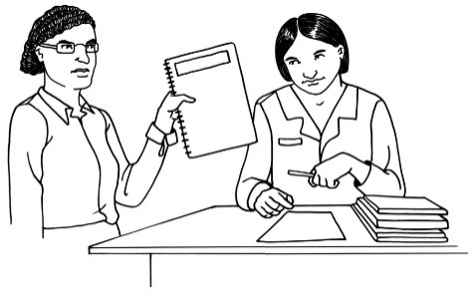

We are going to give the Government this advice in August 2015.

Privacy

We will stick to the rules of the Privacy Act 1993.

Only staff in the Ministry of Social Development and the Ministry of Health working on this review will be able to see your feedback.

Giving out information under the Official Information Act:

Your feedback might be asked for by a person or an organisation under the Official Information Act 1982.

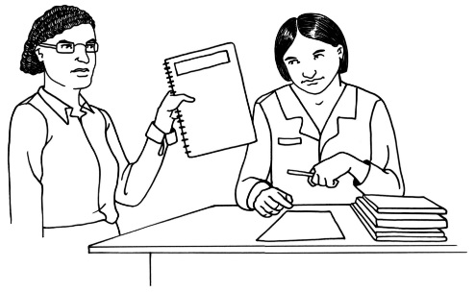
If this happens then the Ministry of Social Development will have to give it out.

Please say on your form if you want your personal information to be taken off your feedback if an Official Information Act request is made.

Your personal details are:

- your name

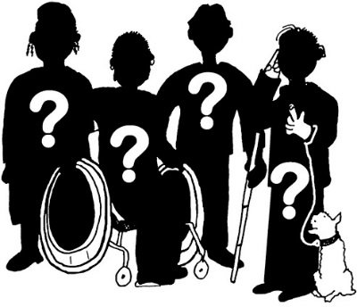
- contact details

- any other information in your feedback that might tell people who you are.

Have your say here.

For some of these questions you can circle the answers that are right for you.
For other questions you will need to write your answers down.

You do not have to write your personal information down if you do not want to.

What is your name?

______________________________
What is your email address?

______________________________
Where do you live?

______________________________________
______________________________________
______________________________________
______________________________________
______________________________________

Circle the right answer below:

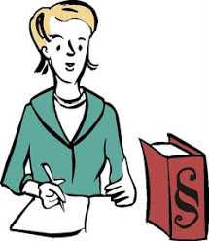
Are you giving feedback for:

- yourself?

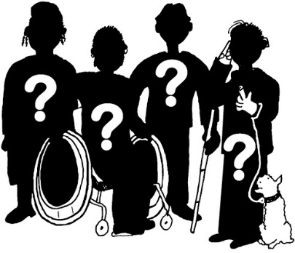
- an organisation?

- a group?
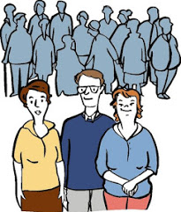
If you are giving feedback from an organisation or group how many people had a say in the feedback?

______________________________

Circle the right answer below:

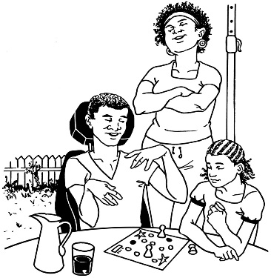
Are you:

- a parent of a disabled child or young person
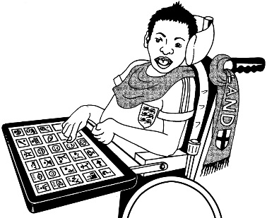
- a disabled child or young person

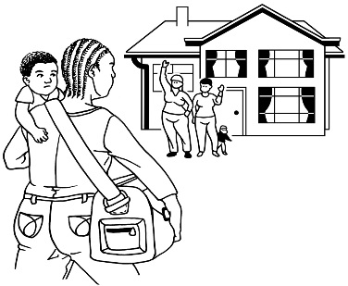
- a disabled person who has lived away from the family home as a child

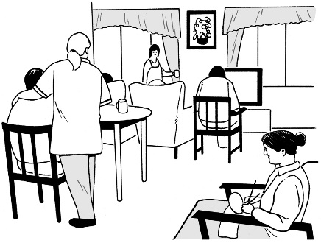
- a disability service or organisation

- other.

If you chose other, please explain here:

______________________________________
______________________________________
______________________________________

Are you ok with someone that is working on this project getting in touch with you to talk about your feedback?

Circle the right answer below:

Yes

No

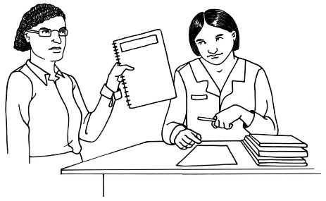
Do you want your personal information to be taken off if your feedback is asked for under the Official Information Act?

Circle the right answer below:

Yes

No

Topic 1
Supporting families who are caring for their child or young person who has very high support needs, at home.

We know that parents and caregivers want to look after their children in the family home, if this is possible.

Many families need support to do this.

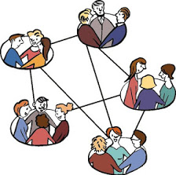
We want to know what families need to be able to care for their disabled children in the family home.

What happens in New Zealand right now?

Families and disabled children get support from many different government departments.

Families, parents and caregivers who are looking after disabled children at home might be able to get some financial support from Work and Income.

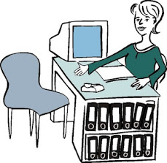
There are some free services in the community that families, parents and caregivers can get help from.

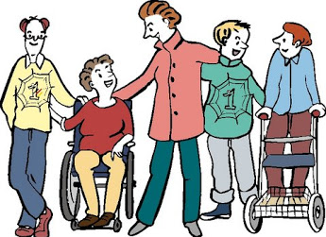
The biggest support that families, parents and caregivers get is often from family or friends who understand what they are going through.

Questions
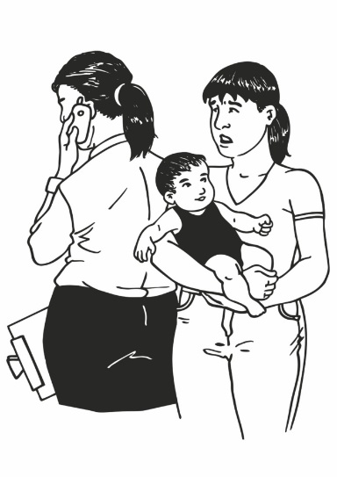
- Some families caring for their child with very high support needs at home have trouble getting the right kind of services and support they need. Why do you think this happens?

__________________________________________________

__________________________________________________

__________________________________________________

__________________________________________________

__________________________________________________

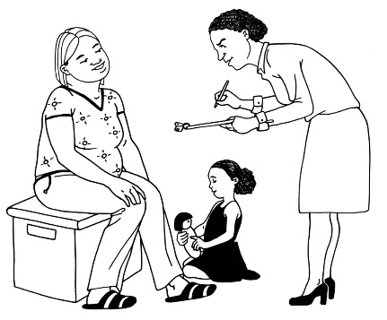
- For families who are supporting their disabled child with very high support needs at home, what kind of support works best for them?

__________________________________________________

__________________________________________________

__________________________________________________

__________________________________________________

__________________________________________________

__________________________________________________

__________________________________________________

__________________________________________________

__________________________________________________

__________________________________________________

- Is there anything else you think would make things better for families caring for their child with high support needs in the family home?

__________________________________________________

__________________________________________________

__________________________________________________

__________________________________________________

__________________________________________________

__________________________________________________

__________________________________________________

__________________________________________________

__________________________________________________

__________________________________________________
Topic 2
How decisions are made about where a disabled child with high support needs will live.

What steps help families make decisions about where their child lives?

What happens in New Zealand right now?

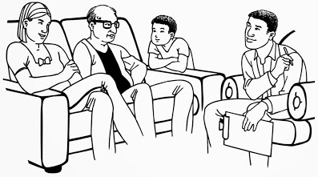
When a family has a child with high support needs an organisation called Needs Assessment and Service Coordination works with them.

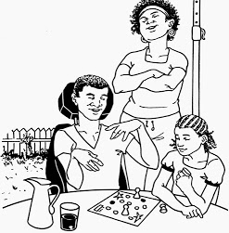
The Needs Assessment and Service Coordination service works with families to find support in the community so their child can live at home.
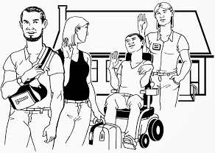
If the family cannot support their child to live in the family home any more this service will help the family find somewhere for their child to live.

The family can then make an application to the Ministry of Health to see what support services are available.

A Child Youth and Family Coordinator will hold a family group meeting to see if there are any other ways a child can stay living in the family home.

If they decide the child must live away from the family home then this will be organised.

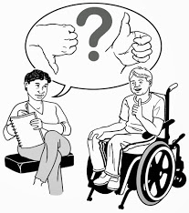
When a child is living in their new home a family group meeting will be held every year to check that the new home is a good place to live.

Parents are the legal guardians of their children until they are 18 years old.

If a child is over 12 years old they should have a say about where they are going to live.

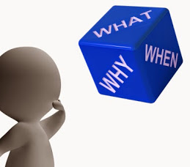
Questions

If we were going to make a new system for placing disabled children and young people into homes away from the family home:

- What would you do differently?

__________________________________________________

__________________________________________________

__________________________________________________

__________________________________________________

__________________________________________________

__________________________________________________

__________________________________________________

__________________________________________________
- Who do you think needs to be part of this new system?

__________________________________________________

__________________________________________________

__________________________________________________

__________________________________________________

__________________________________________________

__________________________________________________

__________________________________________________

__________________________________________________

__________________________________________________

__________________________________________________

- What changes do you think need to be made to The Children, Young Persons and Their Families Act 1989 to make it better for disabled children with high support needs when they need to live away from their families?

__________________________________________________

__________________________________________________

__________________________________________________

__________________________________________________

__________________________________________________

__________________________________________________

__________________________________________________

__________________________________________________

__________________________________________________
Topic 3
Looking after the rights and choices of disabled children and young people when they have to live away from the family home.

We want to know what services and support should be there to make sure:

- moving away from the family home goes ok for disabled children and their families

- families stay in touch with their children.

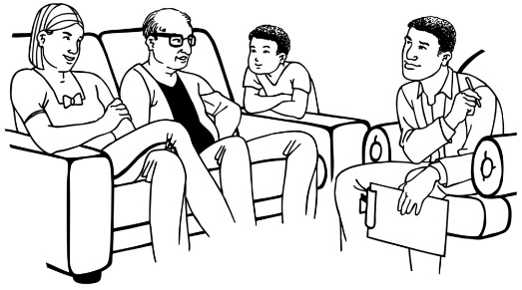
What happens in New Zealand right now?

Families must stay in touch with their children.

Parents are still the legal guardians and make all the decisions for their child.
Questions

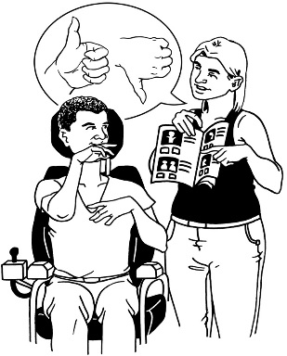
- Could we do anything better to make sure disabled young people living away from home:

- get their human rights?
For example:
  - having their say
  - being safe.

__________________________________________________

__________________________________________________

__________________________________________________

__________________________________________________

__________________________________________________

__________________________________________________

__________________________________________________

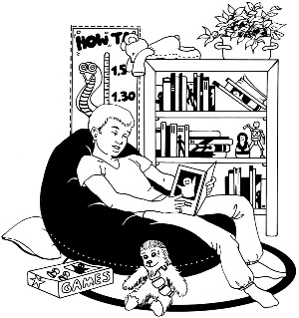
- are supported to do the things they like?

__________________________________________________

__________________________________________________

__________________________________________________

__________________________________________________

- When a disabled child is living away from home and it is going well, why is it working well?

__________________________________________________

__________________________________________________

__________________________________________________

__________________________________________________

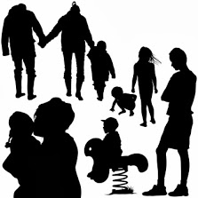
- What makes it easy for families to stay in contact with their children if they are living away from home?

__________________________________________________

__________________________________________________

__________________________________________________

__________________________________________________

- Is there anything else that works well when a disabled child is living away from the family home?

__________________________________________________

__________________________________________________

__________________________________________________

__________________________________________________
Topic 4
When a disabled young person turns 17 and has to change where they are living.

What happens in New Zealand right now?

When a disabled young person lives away from the family home turns 17, there are no laws to say where they should live.

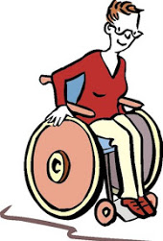

Most of the time these people move into adult support services.

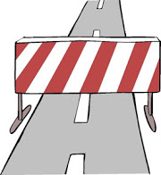
Some people stay living in the same place until they are 21 and then move into adult support services.

Before a young person turns 17 they will have a Needs Assessment.

The Needs Assessment will work out what kind of support is needed to help the young person and their family with the move to a new home.

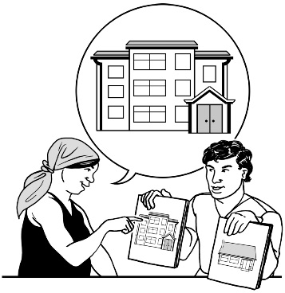
At the Needs Assessment the young person and their family will be told about the different kind of places they can choose to live in.

Questions

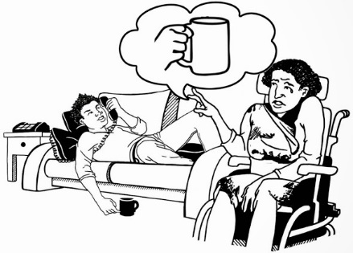
- What kind of support do you think disabled young people need to keep them safe when they are moving to a new place to live?

__________________________________________________

__________________________________________________

__________________________________________________

__________________________________________________

__________________________________________________

__________________________________________________

__________________________________________________

__________________________________________________

__________________________________________________
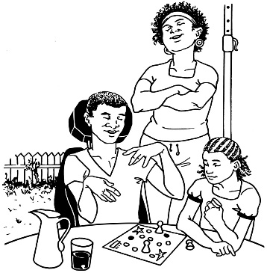
- What do you think could be done better to help young disabled people and their families when this big change is happening?

__________________________________________________

__________________________________________________

__________________________________________________

__________________________________________________

__________________________________________________

__________________________________________________

__________________________________________________

__________________________________________________

__________________________________________________

__________________________________________________

For more information

We can:

- talk to you about how to have your say
- post out information to you.

You can:

- phone us on:
(04) 931 2395

- look online at the Disabled Children Project here:

www.msd.govt.nz/disabled-children-project

- email us at the Ministry of Social Development at:

dcp@msd.govt.nz

This information has been translated into Easy Read
by People First New Zealand Inc.- Ngā Tāngata Tuatahi
