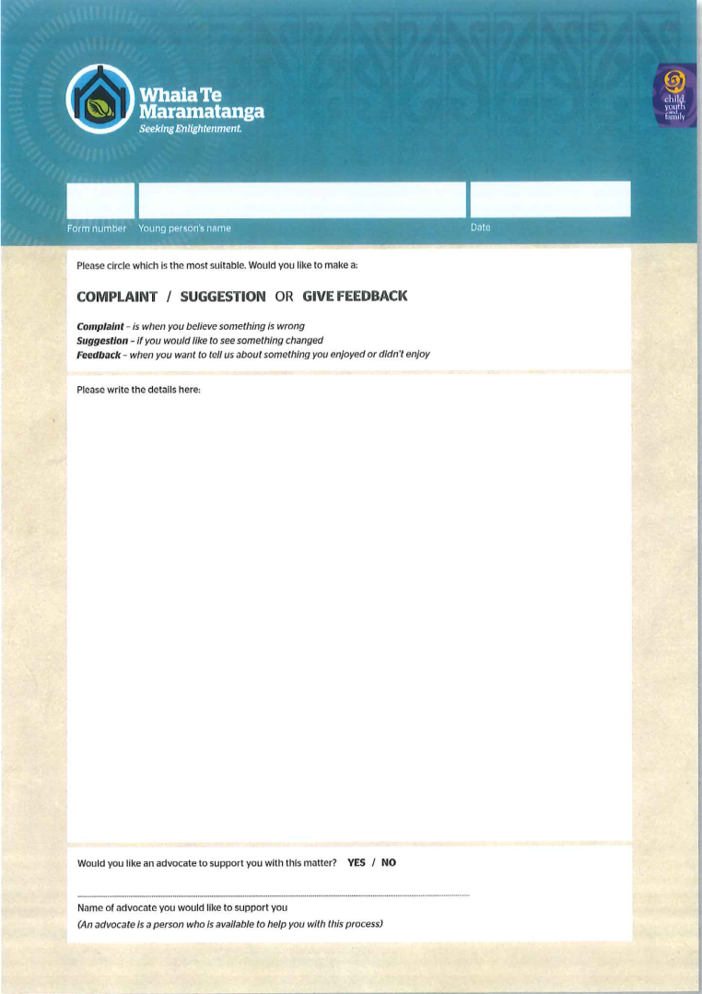
Whaia Te Maramatanga (Grievance) Number:______
Grievance Panel Review/Investigation Report

To | Manager | Child/Young Person
From | Grievance Panel | Date of Grievance
Cc | Grievance Coordinator | Date Review Referred
Investigation Date(s) |  | Date Review Completed
Complaint Type | (Staff - physical/verbal/other/unfair conseq, Other Resident - physical/verbal/other, Food, Property, Other)

Tasks of the investigator
Review: A reconsideration. This requires: the examination of the process utilised; the timeliness of the process against the standard operating procedures and provisions of the Residential Care Regulations; an examination of all documents associated with the investigation; a discussion with the child or young person concerned to ascertain their views; and any clarification necessary with the grievance coordinator or manager as to: policy, regulations, legislative and practice guidelines.

Investigation: An enquiry to establish the truth. This requires all of the above and: conducting interviews of all key informants; an analysis of all relevant documents provided e.g. incident reports and internal records.

Overview/Background of Grievance – include a sequence of events and any relevant contextual issues

Investigation Details
Details of Persons Contacted/ Interviewed – Name, relationship to child/young person, date
Details of the interviews (can attach interview notes/records separately)
List Documentation/ Records checked – files, log books, incident reports and any other relevant documentation. List any relevant policy, procedures and legislation i.e. SOP’s, Regulations (attach copies)

Discussion (analysis of the information gathered leading to the findings; addressing preferred outcome of C/YP)
Provide your findings, giving relevant information gathered from interviews and records

Include reference to the legislation, policies and operating procedures in place at the time of the grievance and whether staff/cyp conformed to these

Findings - tick as appropriate and state the reasons for this decision
Justified | Unjustified

Recommendations ( Any changes in policy or procedures required; practice or performance issues identified)

Signed Panel Member |  | Date
Signed Panel Member |  | Date

